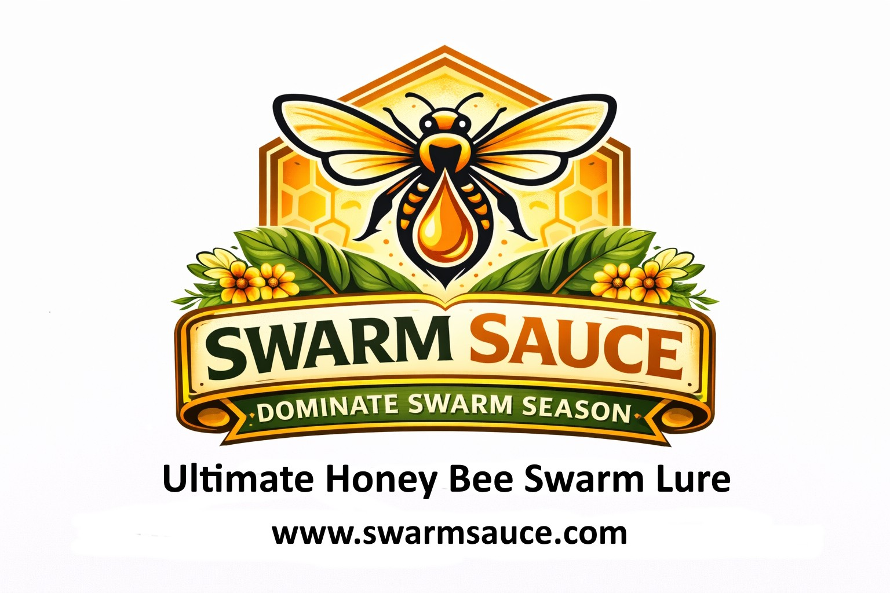
Queenright User Manual
queenrightapp.com · Swarm Sauce · 2026
©2025-2026 Swarm Sauce, LLC - Swarm Sauce® and Queenright® are copyright and registered trademarks of Swarm Sauce, LLC. All Rights Reserved. First use in commerce 10/01/2025.

Contents
Yards — List of yards 3
Add a yard 4
Apiary number — Per yard — not Settings 5
Yard kit — Spares in the truck or barn 6
Hives — List of hives 7
Add a hive 8
Hive card — One colony 9
Hive equipment 10
Hive inspections — List of looks 11
Add an inspection 12
Voice memos 13
Voice commands — English and Spanish 14
Hive treatments 15
Hive feedings 16
Hive harvests — Crop page 17
Hive queen & genetics 18
Hive photos 19
Hive sensors 20
Hive QR lids 21
Reminders 22
Today’s briefing 23
Queenright Learning — The loop 24
Closed call — What the book answered 25
Intervention vs outcome 26
Work stamps the ledger 27
Operations this month 28
Site score, bloom, weight, photo 29
Parked until the book answers 30
Prediction events 31
Swarm rule set 32
Hive → trap coverage 33
Uncovered swarm 34
Search 35
From a sentence — Field assistant 36
Crew & route — Sideliner / Commercial 37
Truck tools — Packed in the truck — Sideliner / Commercial 38
Print / share the route 39
Workload forecast 40
Map — Yards, traps, blooms 41
Swarm traps — List of traps 42
Add a swarm trap 43
Share trap field card 44
Swarm Command Center 45
Season calendar 46
Season readiness 47
Weather surge — Yard clock — not which hive 48
How swarming is decided — The mark is not the score 49
Swarm risk points — Added from the latest look 50
Profit — List of entries 51
Add a profit entry 52
Queen rearing costs 53
Queens — List of rounds (Sideliner / Commercial) 54
Predicted vs actual — Rearing intelligence — Sideliner / Commercial 55
Add a rearing event 56
Cell log — incubator — One line on the round 57
Queen quality 58
Share a yard 59
Share field card 60
Backup 61
Offline 62
Phone & language 63
How data is stored 64
Privacy 65
Terms 66

Yards
List of yards
Instructions:
- Open Queenright at queenrightapp.com and sign in.
- In the left pane or the bottom bar, tap Yard.
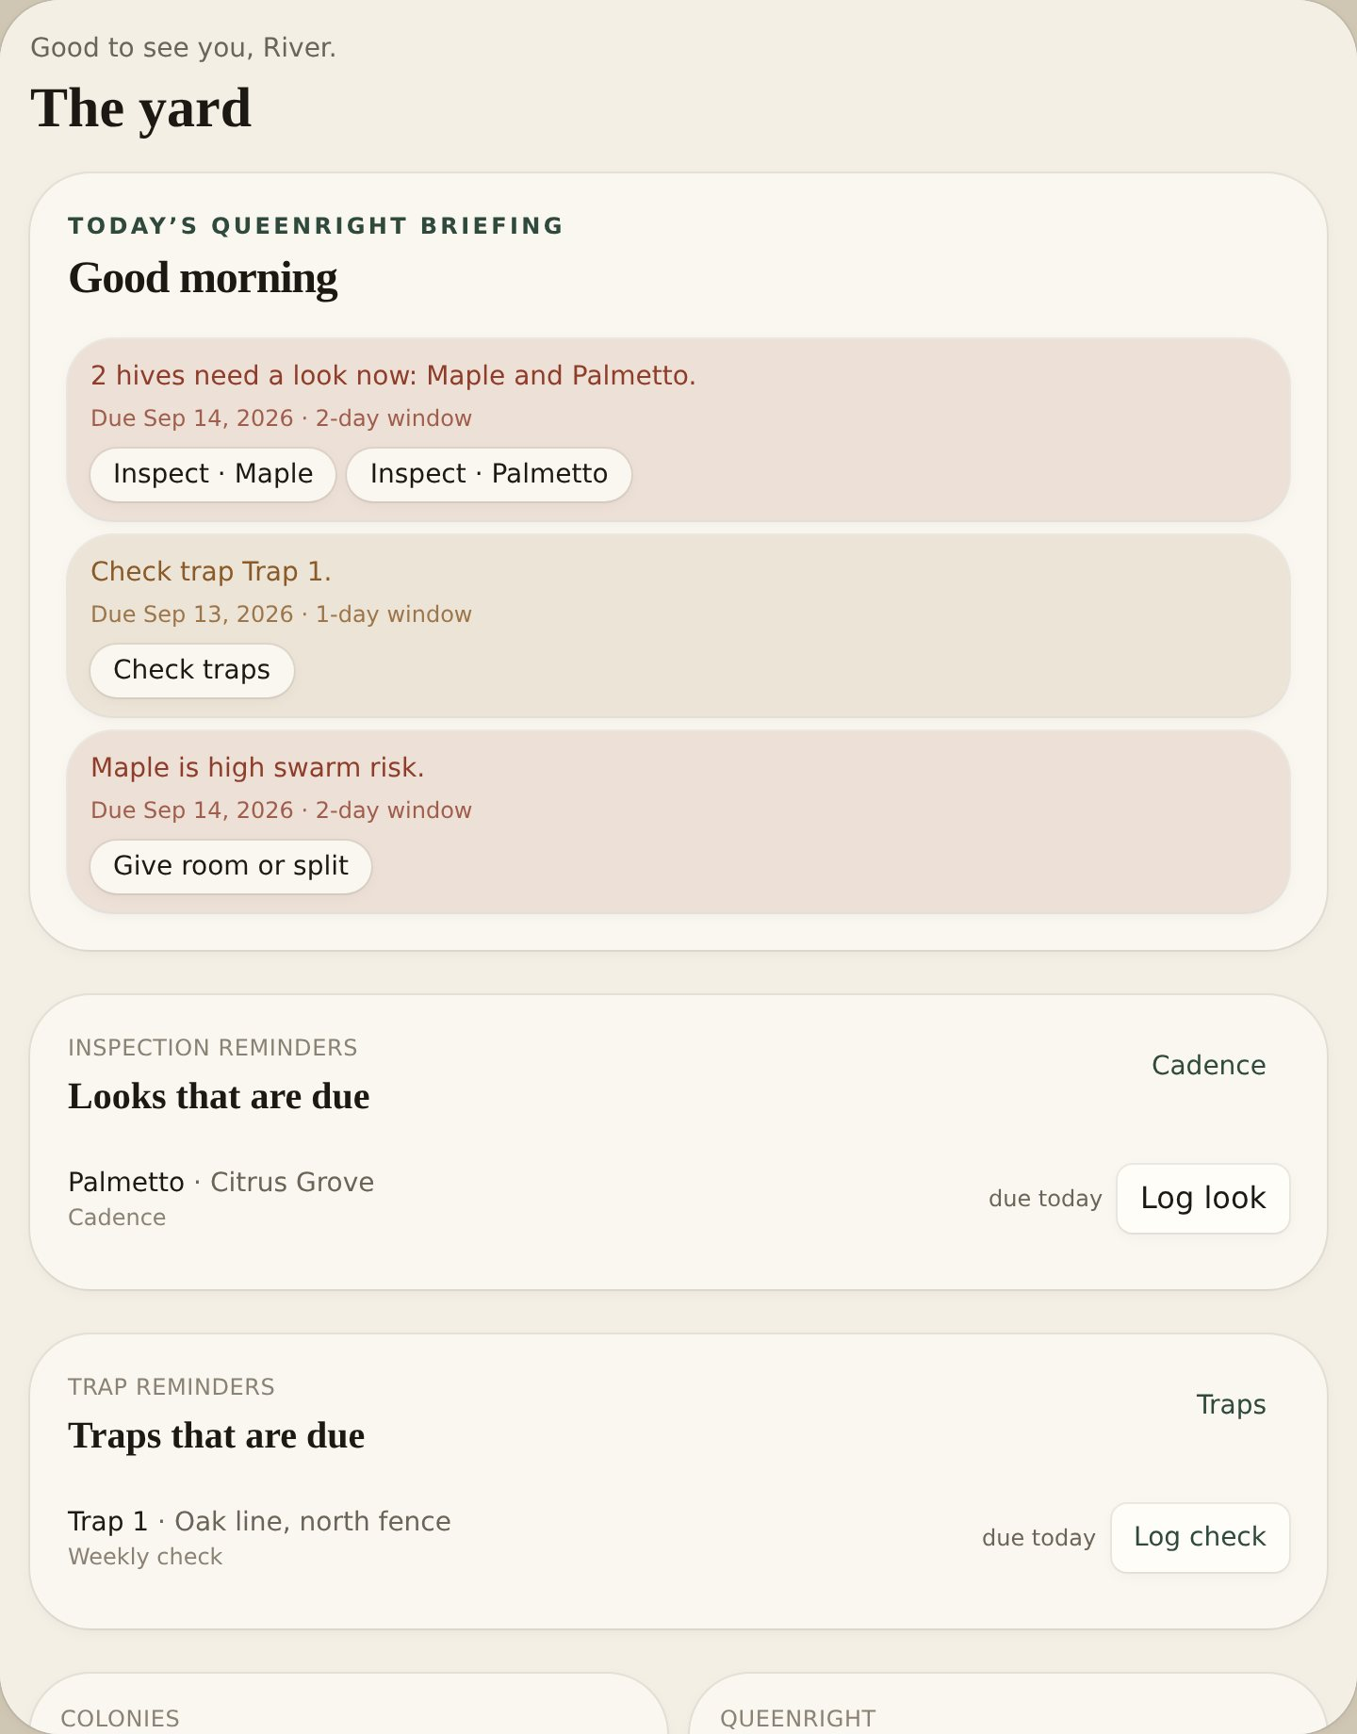
Info:
List of all your yards, weather, briefing, and hives in each yard. Yards sort A–Z.

Add a yard
Instructions:
- On Yard, tap Add yard.
- Add Name, Location, Latitude, Longitude, Forage radius and Notes.
- Add Owner, Address, Phone and Id. Under Owner, add this yard’s Apiary number. It is not the number on Settings — each yard can have a different state number.
- Add Access (gate, dogs, landowner, parking) and Climate.
- Tap Save.
Fields
- Name = name of the yard
- Location = town or place
- Latitude / Longitude = pin for weather and the map
- Forage radius = miles the bees work
- Owner / Address / Phone / Id = landowner or company
- Apiary number = this yard’s state registration (Florida firm number such as FLO 480). Separate from the inspector number on Settings. Lives on Edit yard, not the yard card. Prints and shares on the field card.
- Access = how to get in
- Climate = tropical, dry, temperate, continental, cold winter

Apiary number
Per yard — not Settings
Instructions:
- On Yard, tap Edit. Under Owner, add this yard’s Apiary number (Florida firm number such as FLO 480).
- A yard in another state gets its own number. Do not copy the inspector number from Settings.
- Print field card and Share field card put this yard’s number on the hard copy.
Info:
The yard card does not show the number. Settings → State apiary inspector is who to call for inspections and permits. That number stays on the account and is not sent to the state.

Yard kit
Spares in the truck or barn
Instructions:
- Open the yard.
- Under the hives, This yard’s kit lists spare woodenware A–Z.
- Plus and minus the count. Drawn and foundation frames flag low under 8.
- Hive equipment stays on the hive. Set traps stay on Traps.
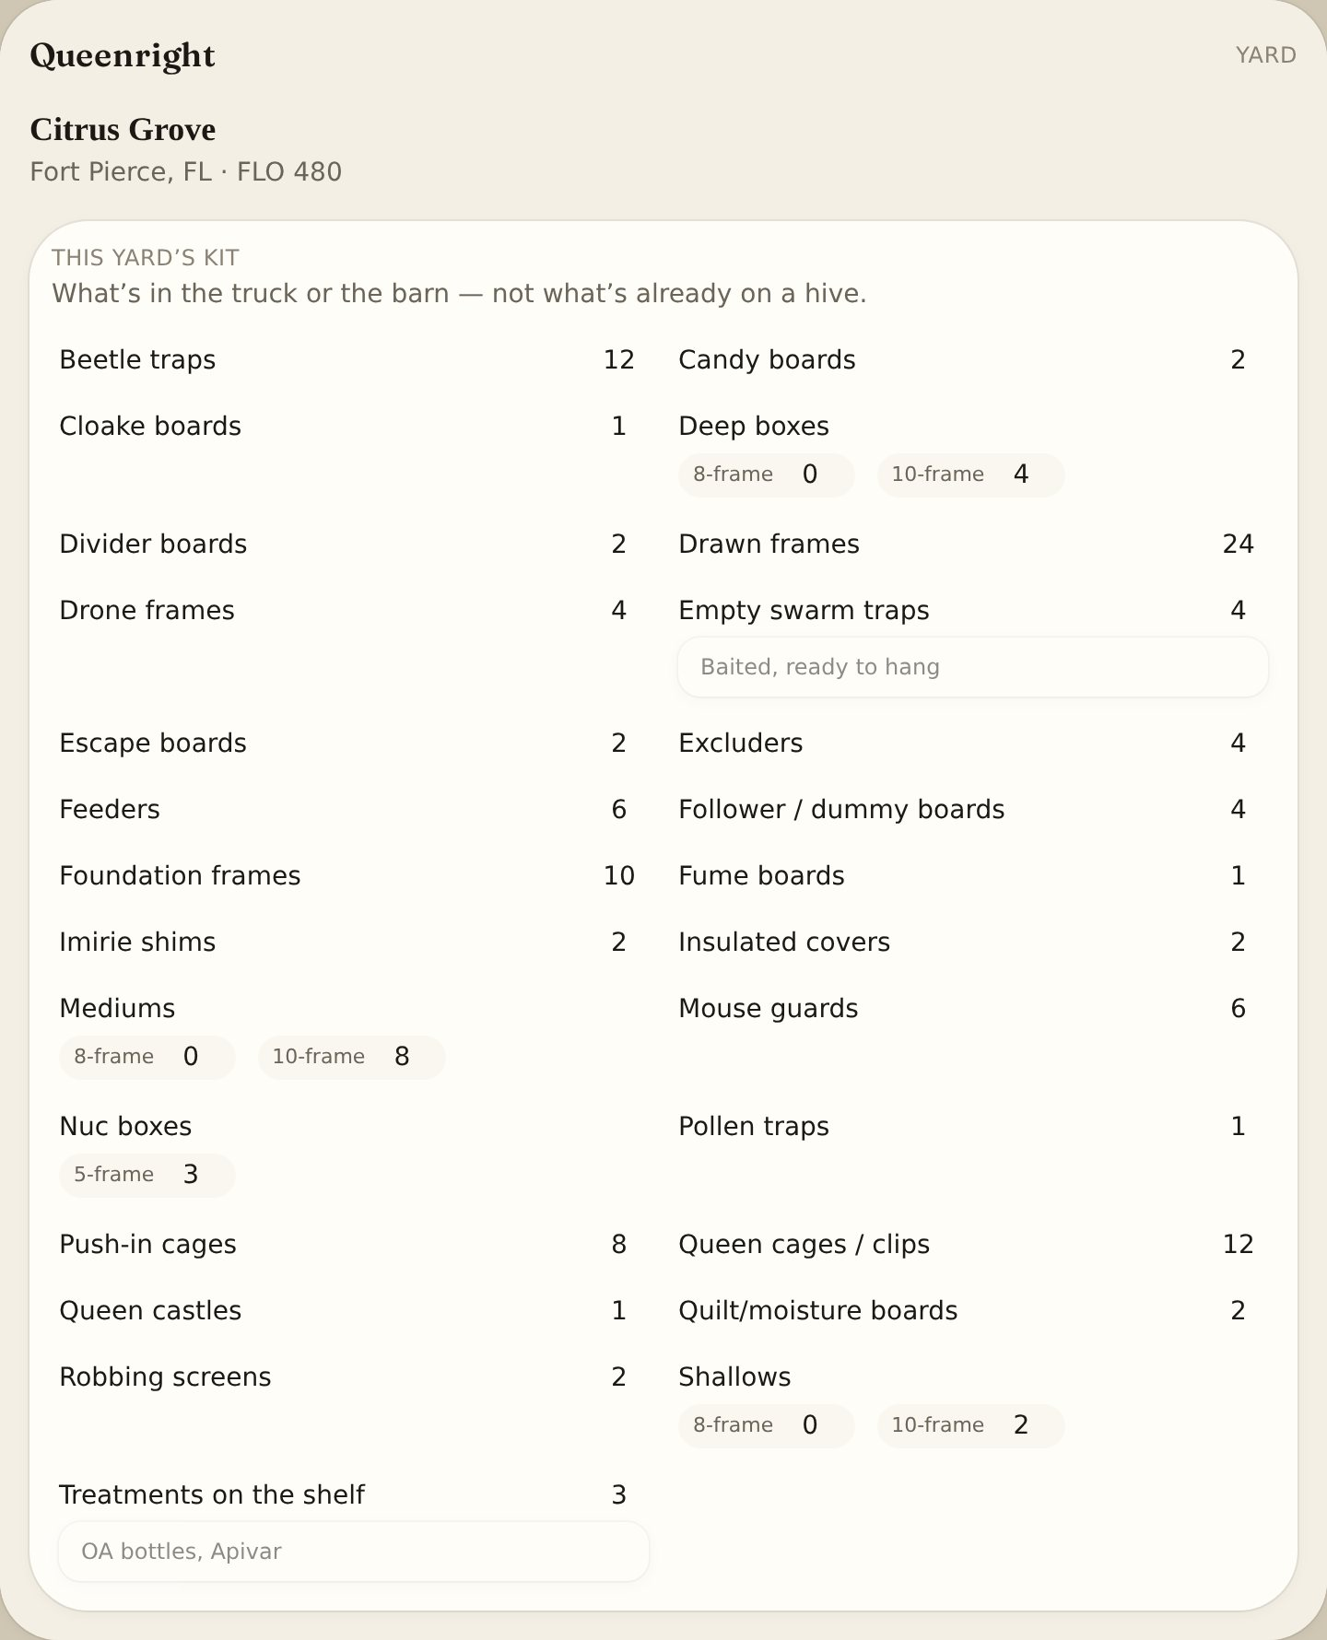
Fields
- Boxes: deeps, mediums, shallows, nucs, empty swarm traps
- Frames: drawn, foundation, drone
- Boards: follower/dummy, divider, candy, Cloake, fume, quilt/moisture, escape
- Pest and harvest: beetle traps, pollen traps, mouse guards, robbing screens
- Queen: cages/clips, push-in cages, queen castles, excluders, Imirie shims
- Other: feeders, insulated covers, treatments on the shelf

Hives
List of hives
Instructions:
- Open Queenright.
- In the left pane or the bottom bar, tap Hives.
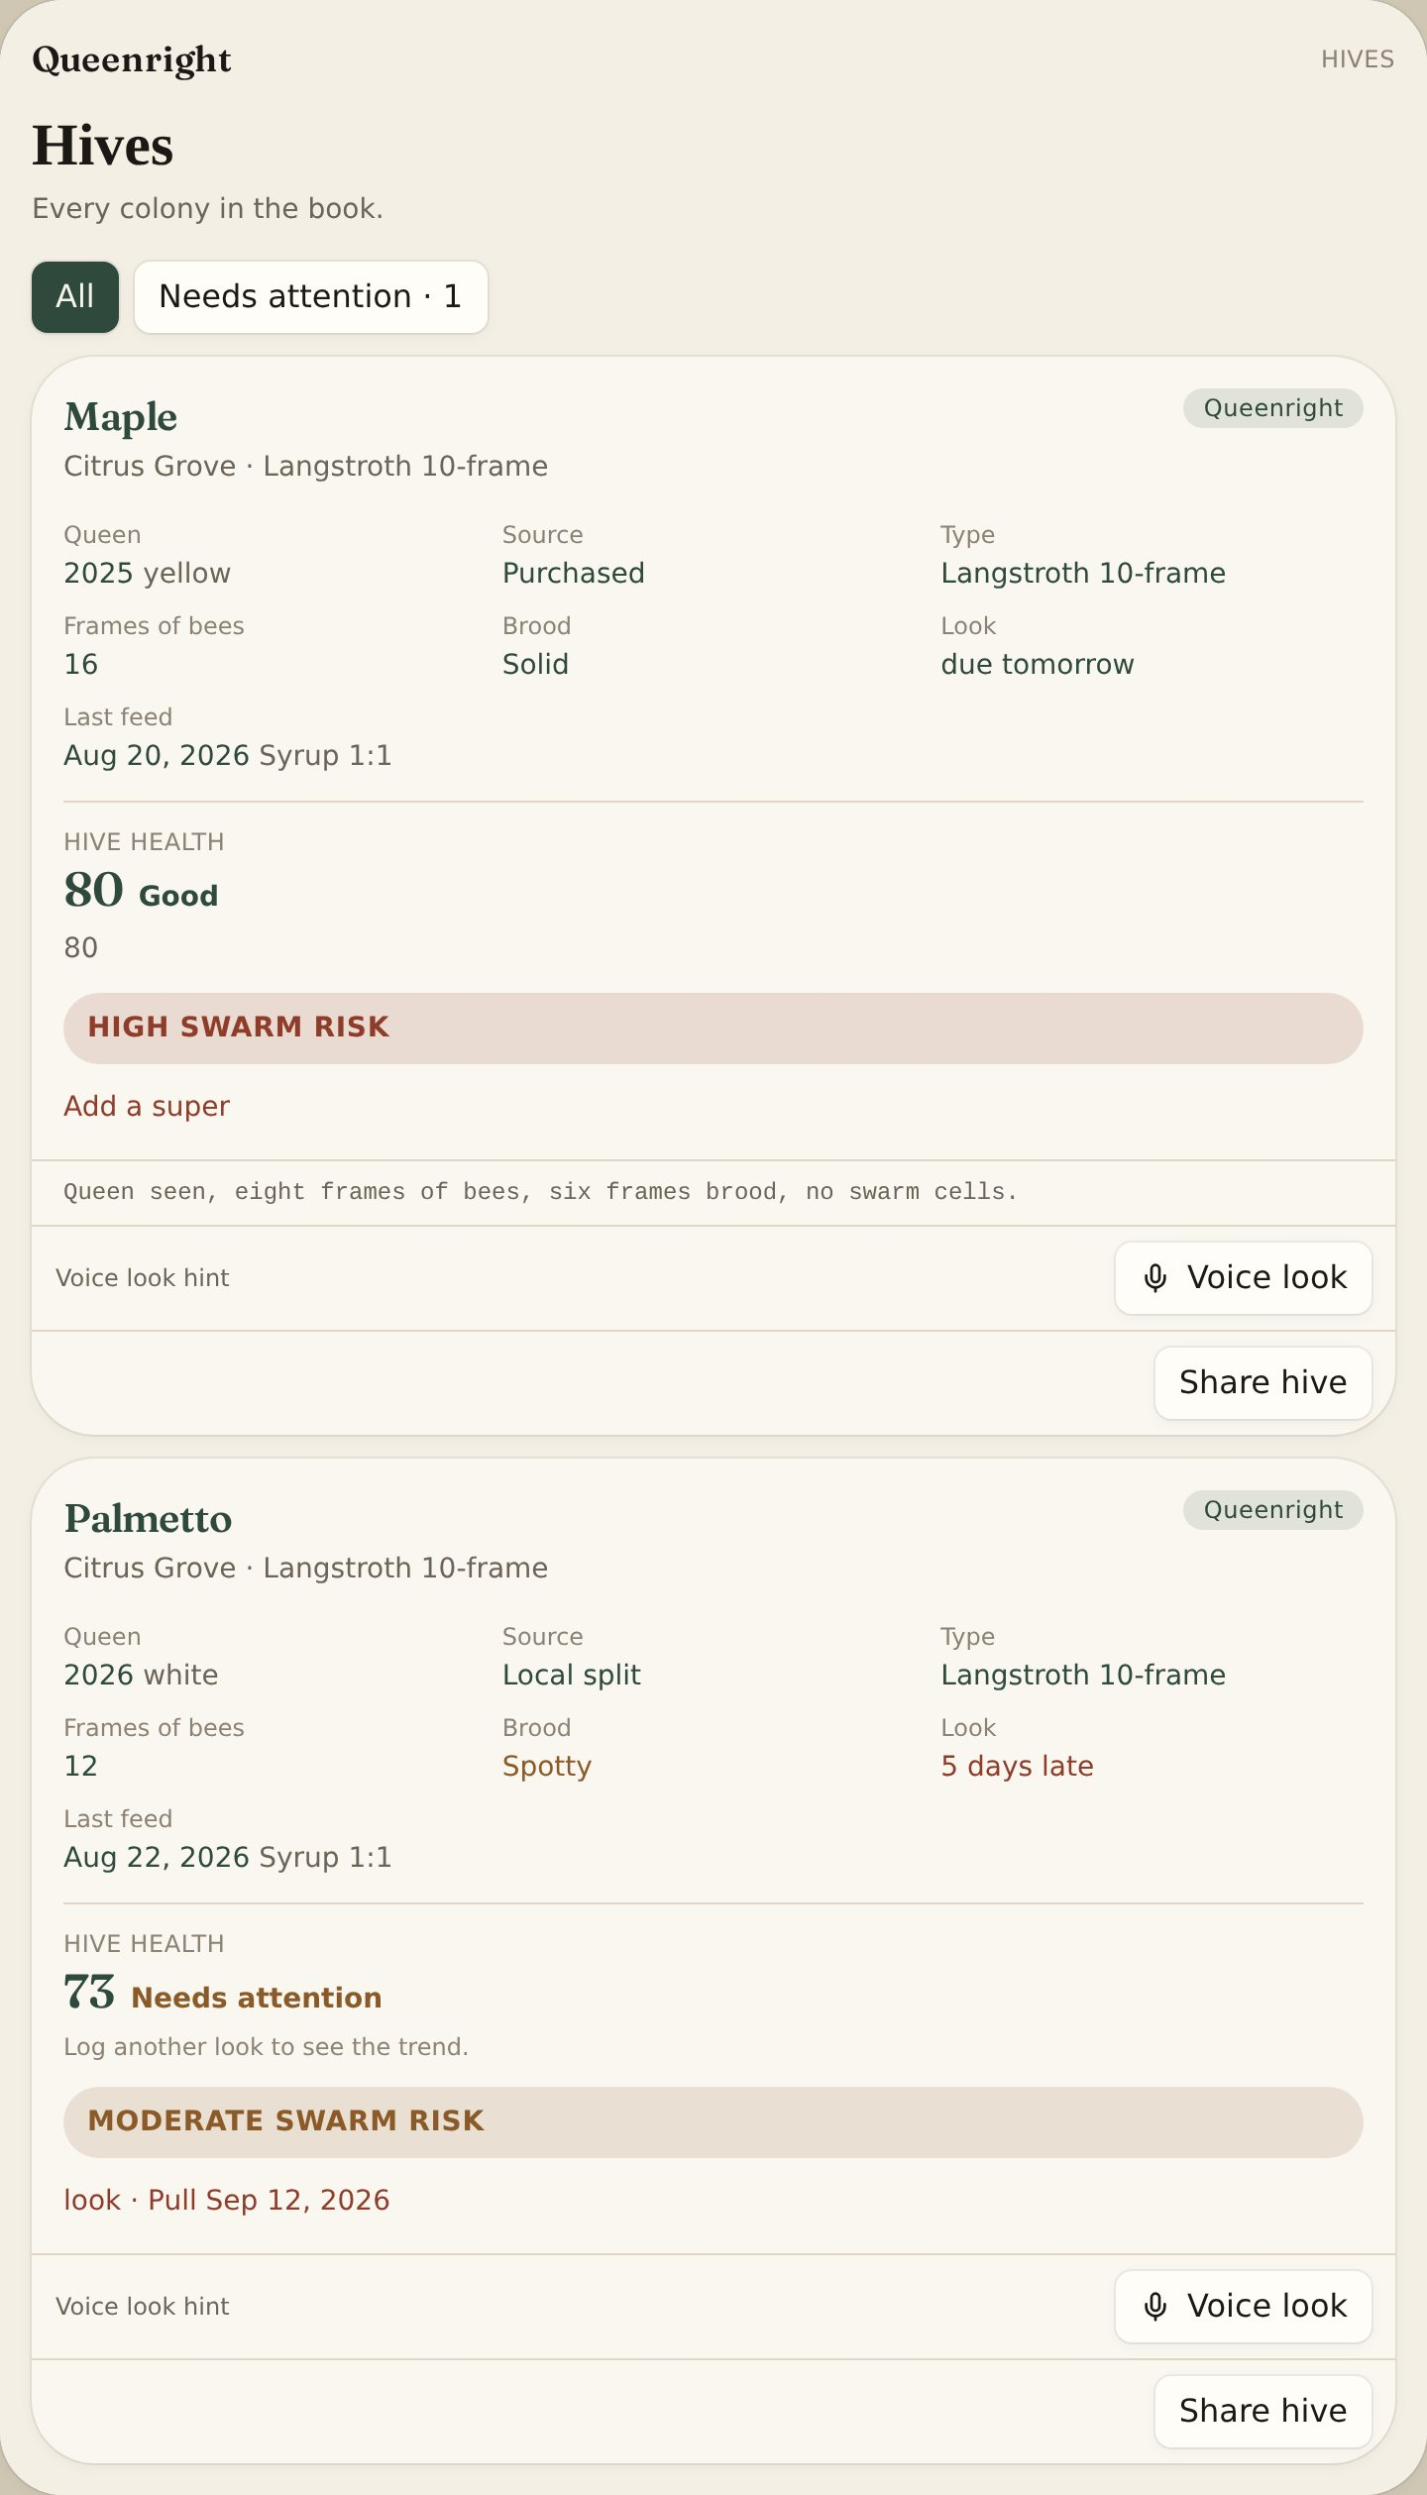
Info:
All colonies, sorted A–Z then by number (10 after 9). Filter with Needs attention. Health score and swarm risk show on the card.

Add a hive
Instructions:
- On Hives or a yard, tap Add hive.
- Add Name, Yard, Type (8 or 10 frame), Status and Origin.
- Add Queen year, mark color and source (including Feral or Donated to yard).
- Tap Save.
Fields
- Name = hive number, tag or name
- Type = Langstroth 8 or 10, nuc, top bar, other
- Status = queenright, queenless, swarming, deadout, absconded
- Origin = package, nuc, swarm, split, purchased, donated, feral
- Queen source / year / color = genetics on the card

Hive card
One colony
Instructions:
- On Hives, tap a hive name.
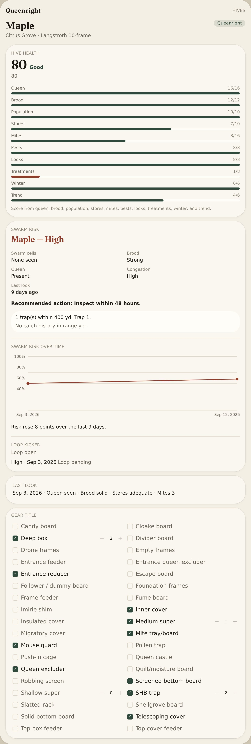
Info:
Health score, swarm risk timeline, colony state timeline, event graph, last look, last feed, treatments, genetics, photos, sensors, voice memos, equipment checkmarks and box counts live here — not on the hive list.

Hive equipment
Instructions:
- Open the hive.
- The equipment list is A–Z. Tap a checkbox for what’s on that box.
- Plus and minus only Deep box, Medium super, Shallow super, and SHB trap.
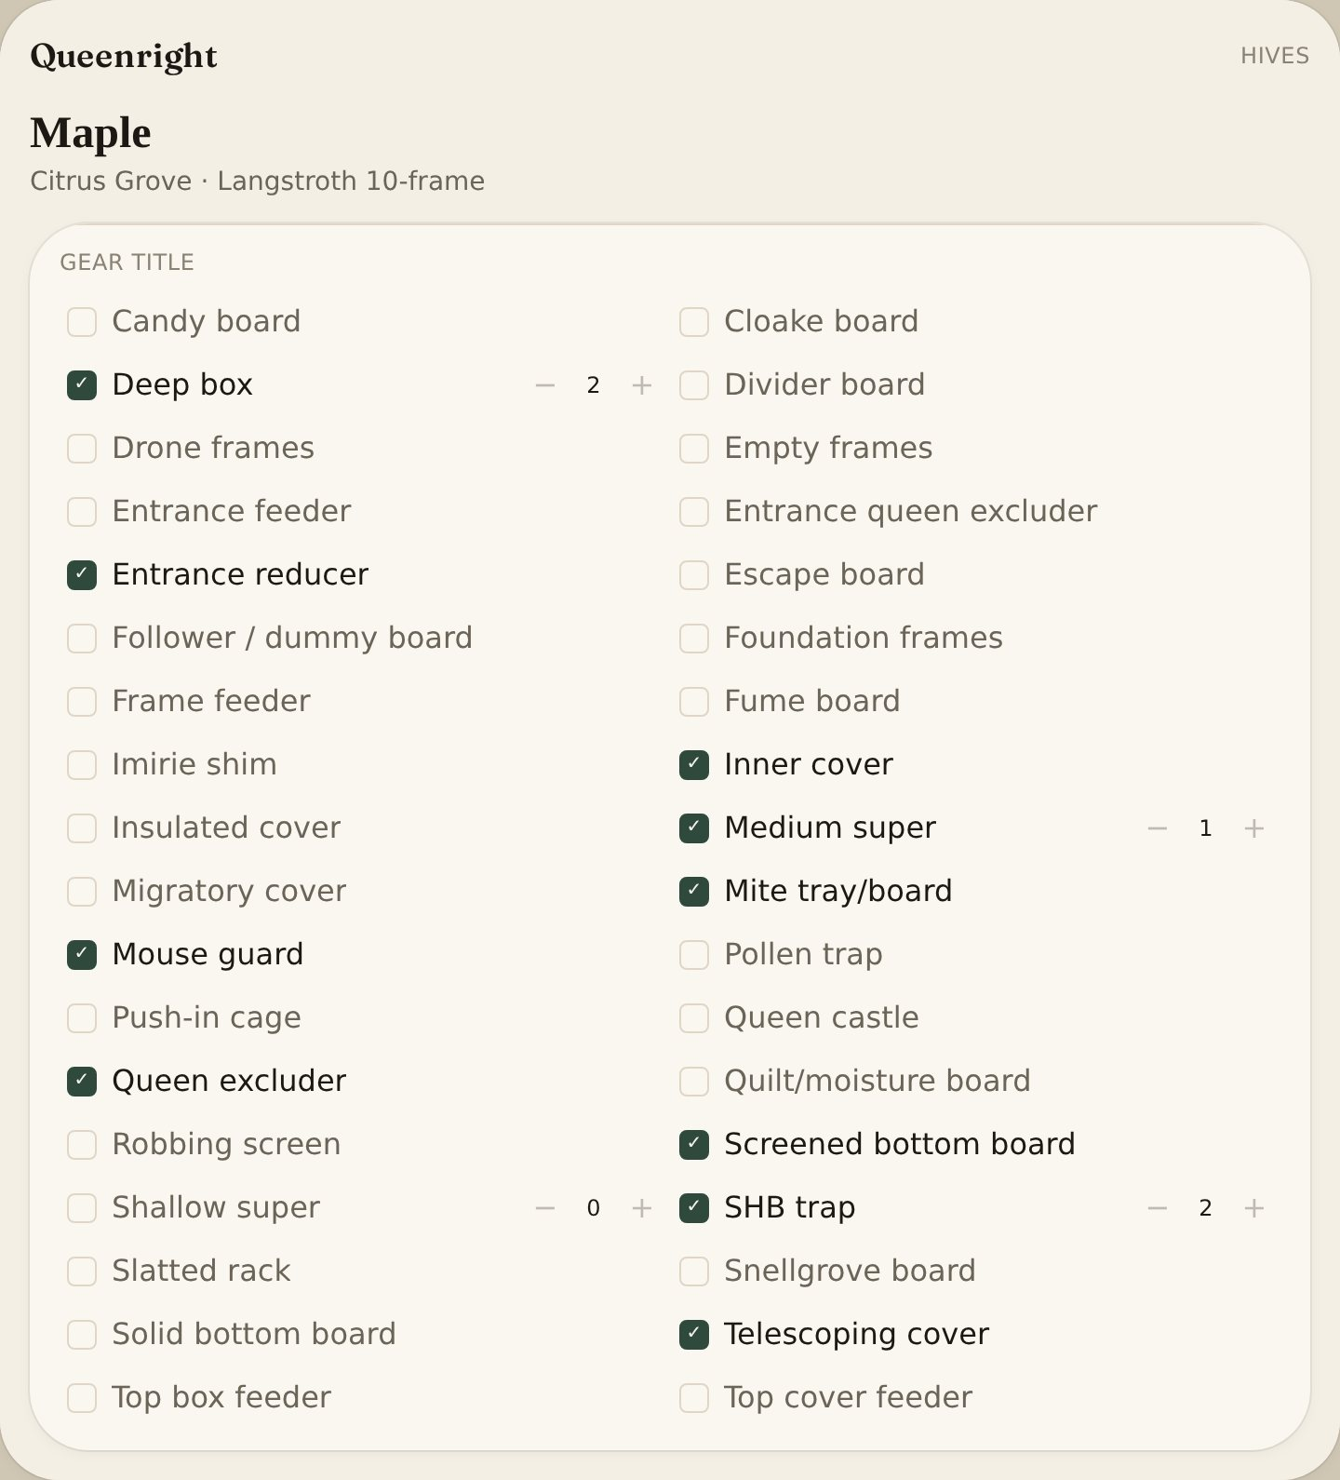
Fields
- Bottoms: solid or screened, mite tray/board, slatted rack
- Covers: inner, migratory, telescoping, insulated, quilt/moisture
- Entrance: reducer, mouse guard, robbing screen
- Frames: foundation, empty, drone frames
- Queen / split: excluder, entrance excluder, Snellgrove, Cloake, Imirie shim, follower/dummy, divider, queen castle, push-in cage
- Feed and harvest: four feeder types, pollen trap, escape board, fume board, candy board
- Counts: deep box, medium super, shallow super, SHB trap — spare counts live on This yard’s kit

Hive inspections
List of looks
Instructions:
- In the left pane or the bottom bar, tap Log.
- Use the search box to find an old look.
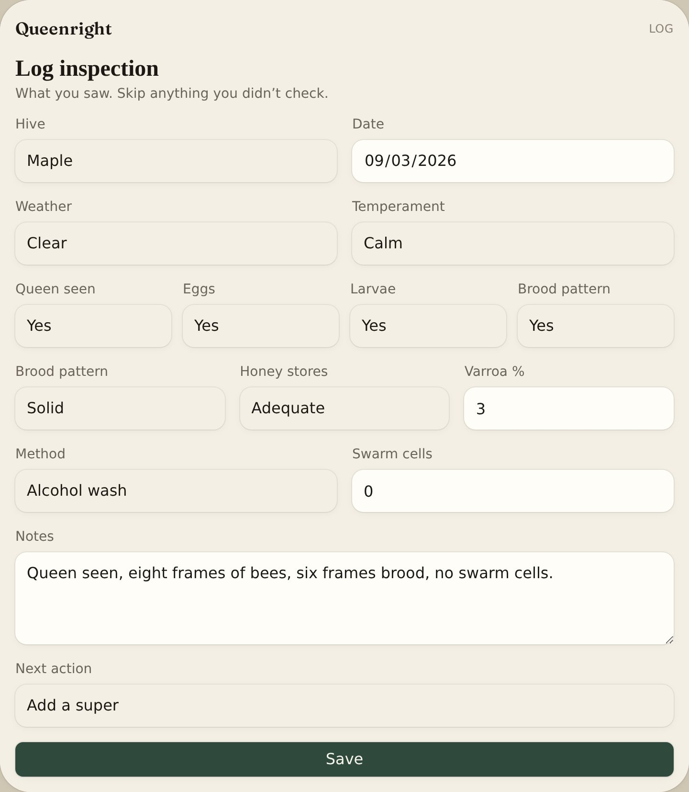
Info:
Every inspection across the operation. Open a hive to add a new one.

Add an inspection
Instructions:
- Open the hive and tap Add look.
- Set Date, Queen, Brood pattern, Population, Stores, Swarm cells, Mites, Pests and Next action.
- Add one or two photos.
- Or hold the microphone and speak the look.
- Tap Save. Offline drafts upload when you have signal.
Fields
- Queen = seen, not seen, cells, queenless
- Brood / population / stores = frames or score
- Swarm cells = none or present
- Mites = count from the last sample
- Next action = add a super, feed, requeen, pull strips

Voice memos
Instructions:
- Open the hive.
- Tap Record.
- Play it later at home. Files stay on this phone.
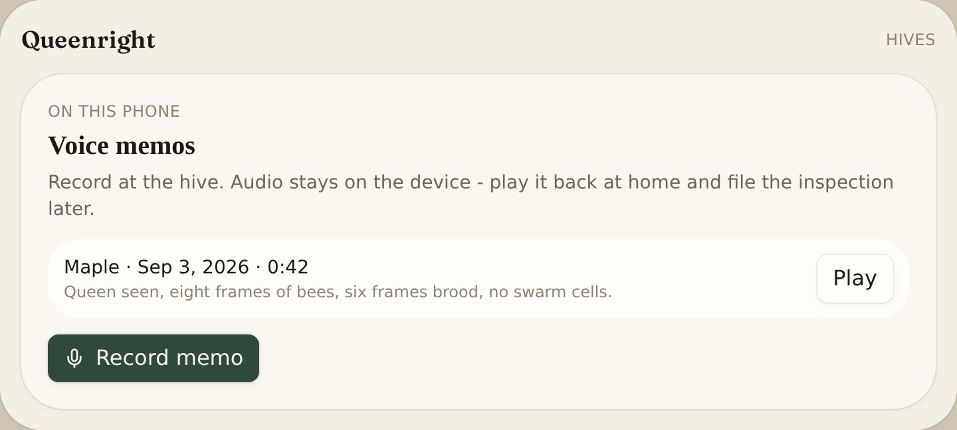
Info:
Field notes when you cannot type. Not uploaded.

Voice commands
English and Spanish
Instructions:
- In Settings, How to use, or Sign in, pick English or Español. The mic follows that language.
- Tap the microphone at the bottom of the screen. Chrome or Safari.
- Name the hive the way it is in the book.
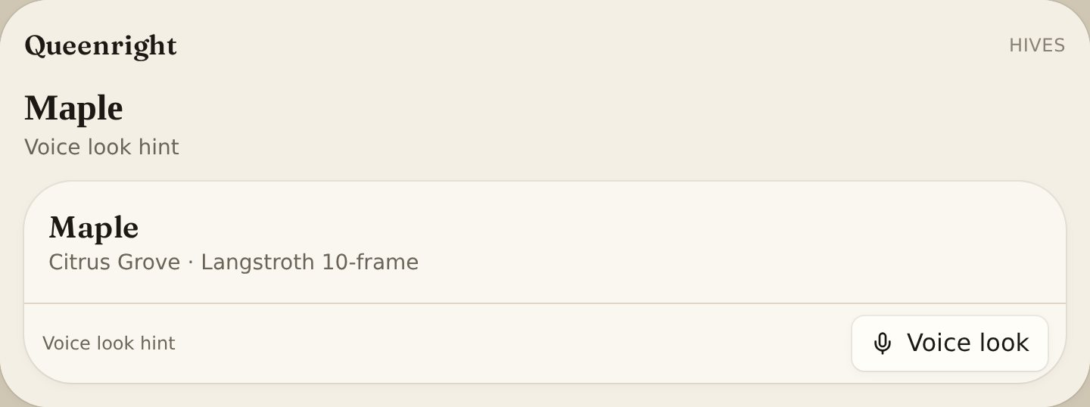
Info:
Say the same command in either language. Commands fill the inspection form. Voice memos are recordings you play back — a different thing. No signal? A spoken look waits on the phone and uploads later. Hive names stay as you typed them.
Fields
- English: “Inspect Maple, calm, queen seen, eggs, mites 1.2”
- English: “Open Palmetto” · “Season” · “Map” · “Traps” · “The log” · “The yard”
- Español: “Revisa Maple, tranquila, reina vista, huevos, ácaros 1.2”
- Español: “Abre Palmetto” · “Temporada” · “Mapa” · “Trampas” · “La bitácora” · “El apiario”
- Plan: “Put two more swarm traps around the north side tomorrow and check Hive 14 Friday.”
- Plan: “Pon dos trampas al norte mañana y revisa colmena 14 el viernes.”
- Voice look on the hive card takes the same English or Spanish words.

Hive treatments
Instructions:
- Open the hive or the yard.
- Tap Log treatment.
- Pick the product (including Small Hive Beetle, Wax Moth, Ants).
- Set Pull strips if the treatment comes out later.
Fields
- Product = the treatment from the list — not Other unless it is other
- Pull strips = date the strips come out; mark pulled on the hive
- Yard log = all live hives in this yard when that box is on

Hive feedings
Instructions:
- Open the hive.
- Tap Feed.
- Set Date, Type (syrup, fondant, pollen), Amount (including oz and cups).
Info:
Last feed shows on the hive card.

Hive harvests
Crop page
Instructions:
- In the left pane, tap Crop.
- Tap Add harvest.
- Set Hive, Date, Pounds, Moisture and Flow.
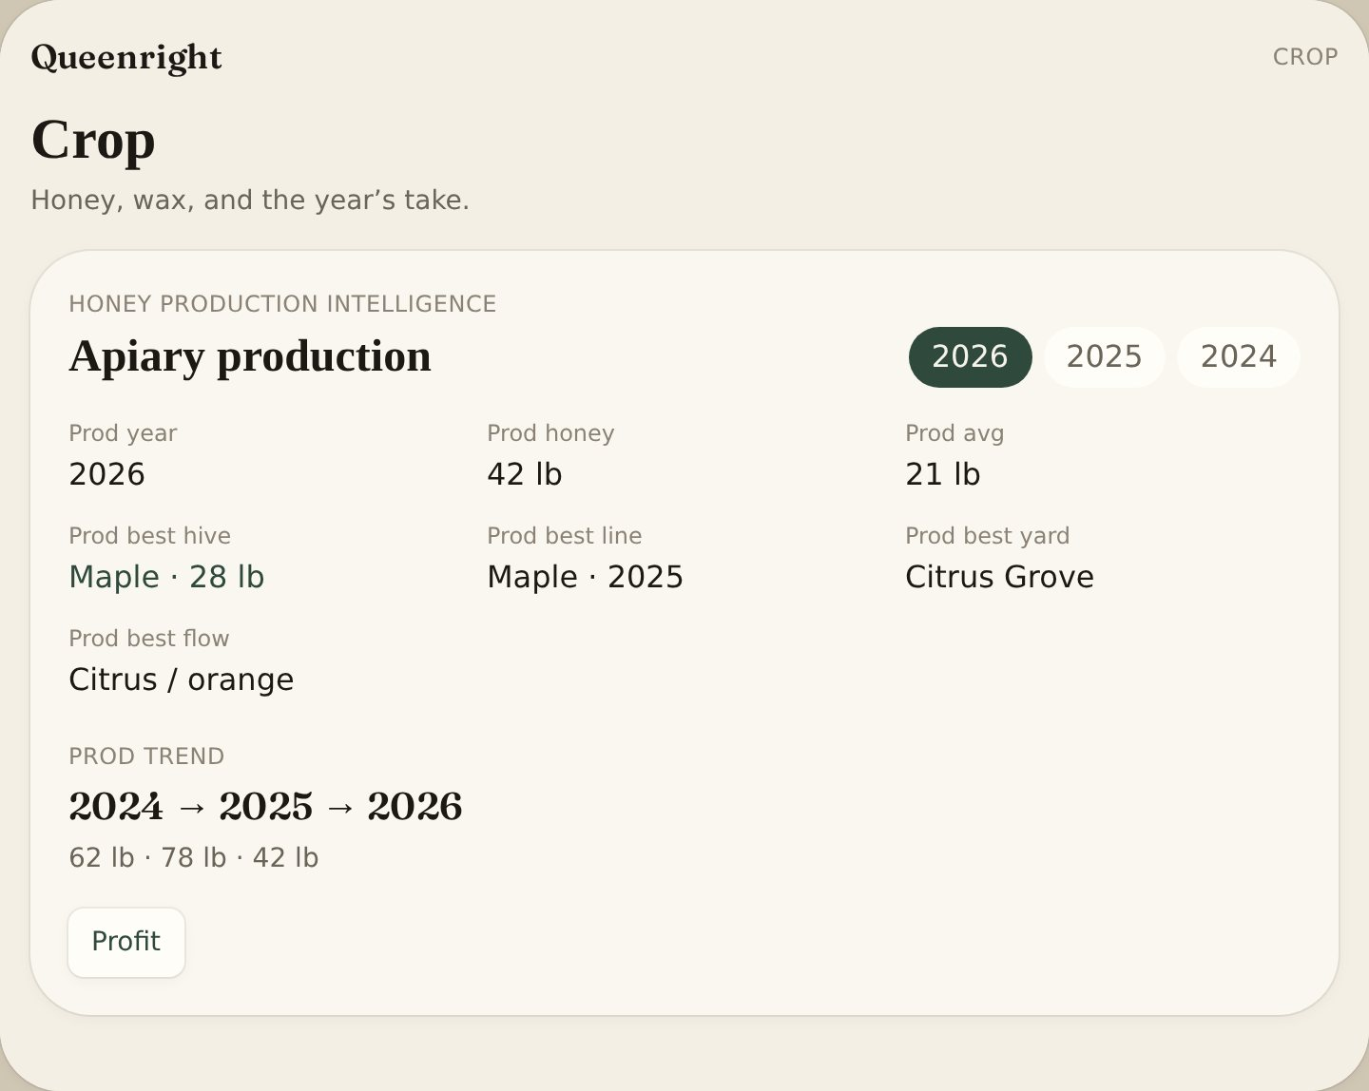
Info:
Honey production intelligence totals the year, average hive, best hive, best queen line, best yard and best flow. Years appear as you harvest.

Hive queen & genetics
Instructions:
- Open the hive.
- In Genetics, set Queen source, Breeder, Mother, Drone source, Mating yard, II, and stock line.
Fields
- Stock = Italian, Carniolan, Russian, VSH, survivor, local, hybrid, feral
- Queen history = introductions and supersedure on this box

Hive photos
Instructions:
- Open the hive.
- Add photos. Save to the phone gallery if you want a copy.
- Tap Read picture when Grok is wired on the host.
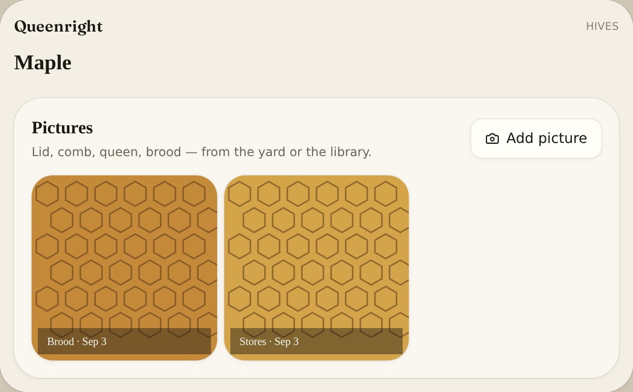
Info:
Suggestions only. Verify in the box. Limit is per hive so the book stays light.

Hive sensors
Instructions:
- Open the hive.
- Tap Pair sensor.
- Choose BroodMinder, BEEP, Govee, SensorPush, Inkbird or generic BLE.
- Stand next to the hive. Readings store with that colony.
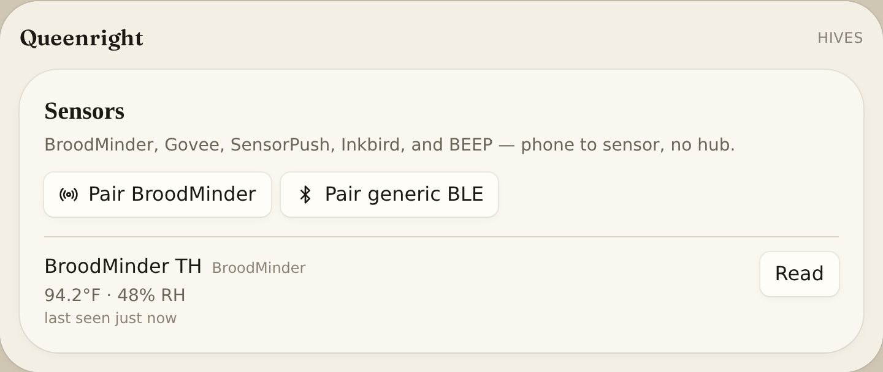
Info:
No paid hub or gateway. Queenright talks phone-to-sensor — not through a BroodMinder hub, BEEP base, or HiveTracks-style collector. Chrome or Edge on Android, or a desktop with Bluetooth, over https (queenrightapp.com). Safari and the iPhone Home Screen app cannot pair.

Hive QR lids
Instructions:
- On Hives, tap Print QR lids.
- On the phone app use Print, Share or Save.
- Scan the code to open that hive.
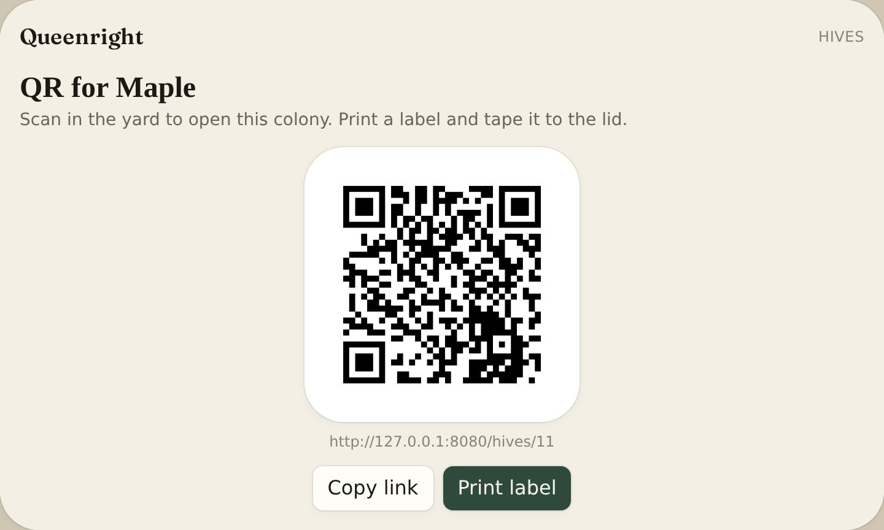

Reminders
Instructions:
- Open Settings.
- Set inspection days and trap check days.
- Due dates show on cards, the briefing and Season.
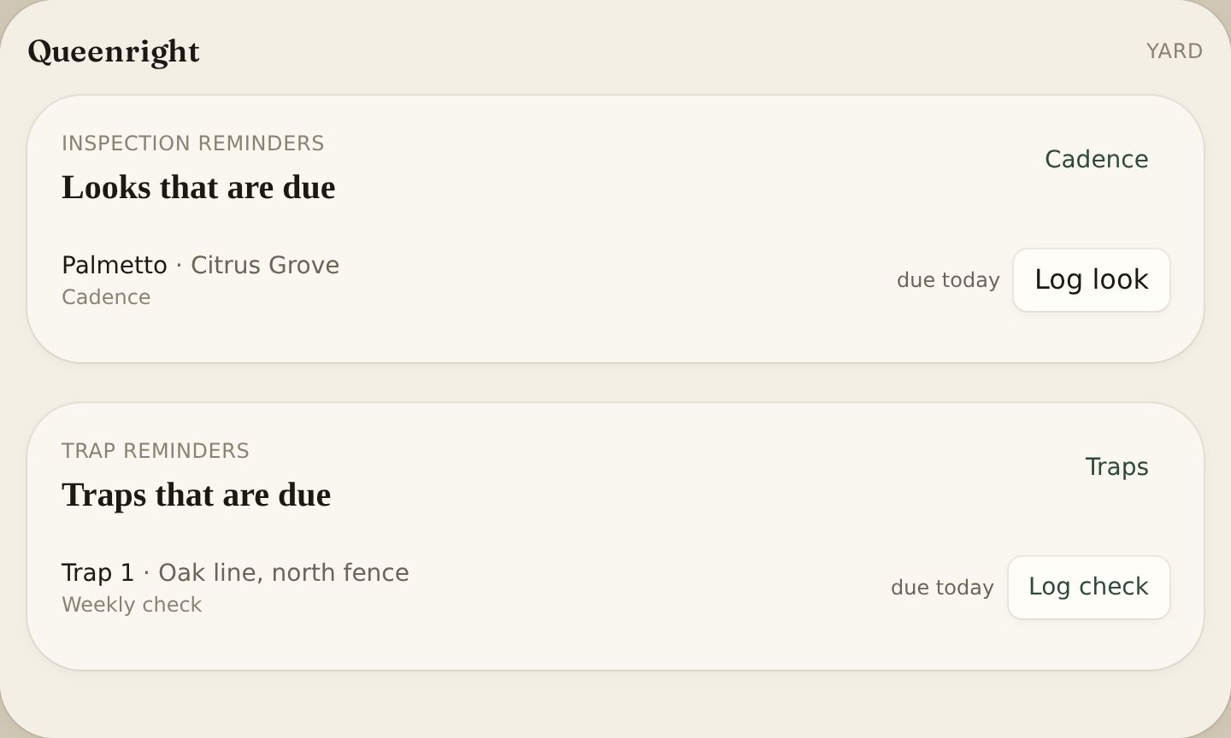

Today’s briefing
Instructions:
- Open Yard.
Info:
Queenright Intelligence lists hives that need you, looks due, traps to check, strips to pull, harvest-ready boxes, high swarm risk, and uncovered swarms. Each line is a Prediction Event. Tap Happened, Did not, or Too early — or log the work and Queenright closes the call.

Queenright Learning
The loop
Instructions:
- Open Yard and read the briefing one-liner: which rule, window days, coverage ring.
- Do the work in the yard — look, split, super, pull strips, harvest, or set a trap.
- Or tap Happened / Did not / Too early on the line.
- Read the accuracy strip: swarm, mating, catch, and uncovered-swarm calls this month.
Info:
Queenright does not predict the nation’s bees. It remembers what it told this yard, what you did, what happened, and whether a box was even there — then it writes a slightly better rule. Record → Understand → Predict → Act → Outcome → Learn.

Closed call
What the book answered
Instructions:
- Open Log. Under the search box, read What the book answered.
- Crop shows the same card under Operations.
- Queenright fills predicted, why, what you did, observed, outcome, assessment, and whether a named rule moved — from the ledger. No extra form.
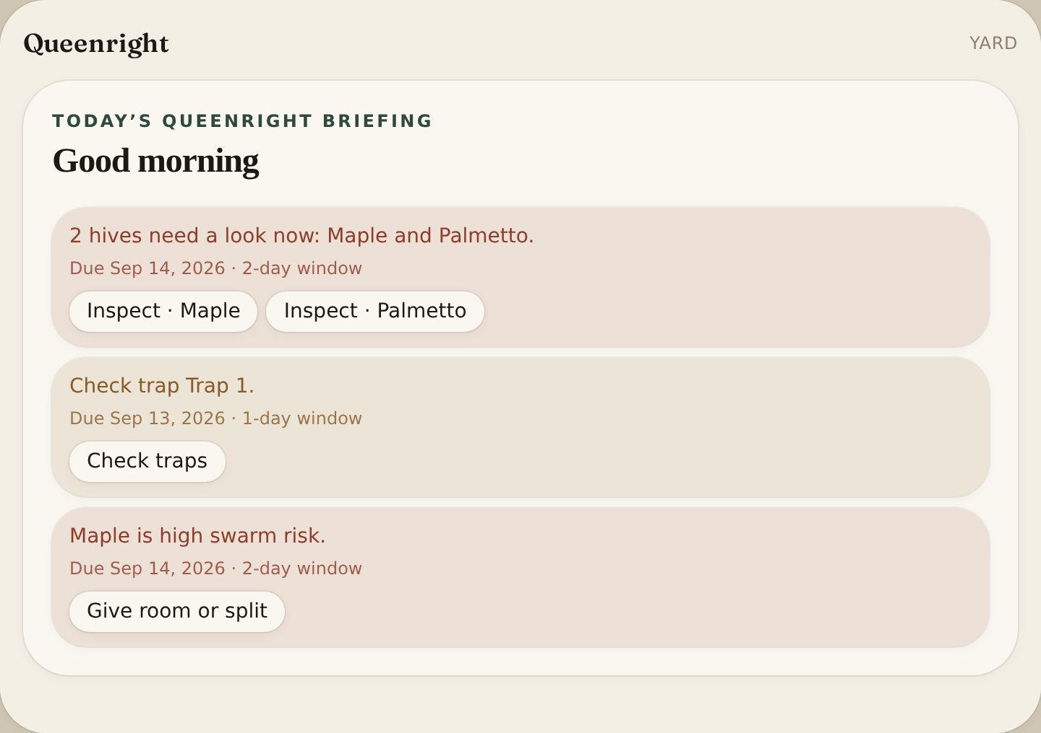
Info:
Happened / Did not on Yard still means did a swarm leave. The card splits Observed from Prediction assessment. A named swarm rule only moves after eight closed swarm calls.

Intervention vs outcome
Instructions:
- Log a split, super, pulled cells, or requeen on the hive. That is an intervention.
- A look, feed, harvest, treat, task, or nothing is not an intervention.
- On Yard tap Did not if no swarm left, or Happened if it did.
Fields
- No swarm after split / super / pulled / requeen = prevented. Assessment: Supported — intervention changed trajectory. Counts as right. High does not go up.
- Swarmed after that work = Supported — the risk was real; intervention did not stop it.
- Swarmed, no intervention = Supported — the call was right.
- No swarm, no intervention = Not supported — false alarm. After eight closes, High can go up.
- Uncovered swarm: setting a pinned trap is the intervention.
- If the split was never written, the book treats it as no intervention.

Work stamps the ledger
Instructions:
- Save tasks (From a sentence or Add task) to open a call: inspect, feed, treat, traps, harvest, or strips.
- Open Crew. Daily route opens one call per yard on tomorrow’s list.
- On Season, Season readiness opens a call for each red gap.
- Log a look, feed, treatment, harvest, pull strips, trap check, or check off the task.
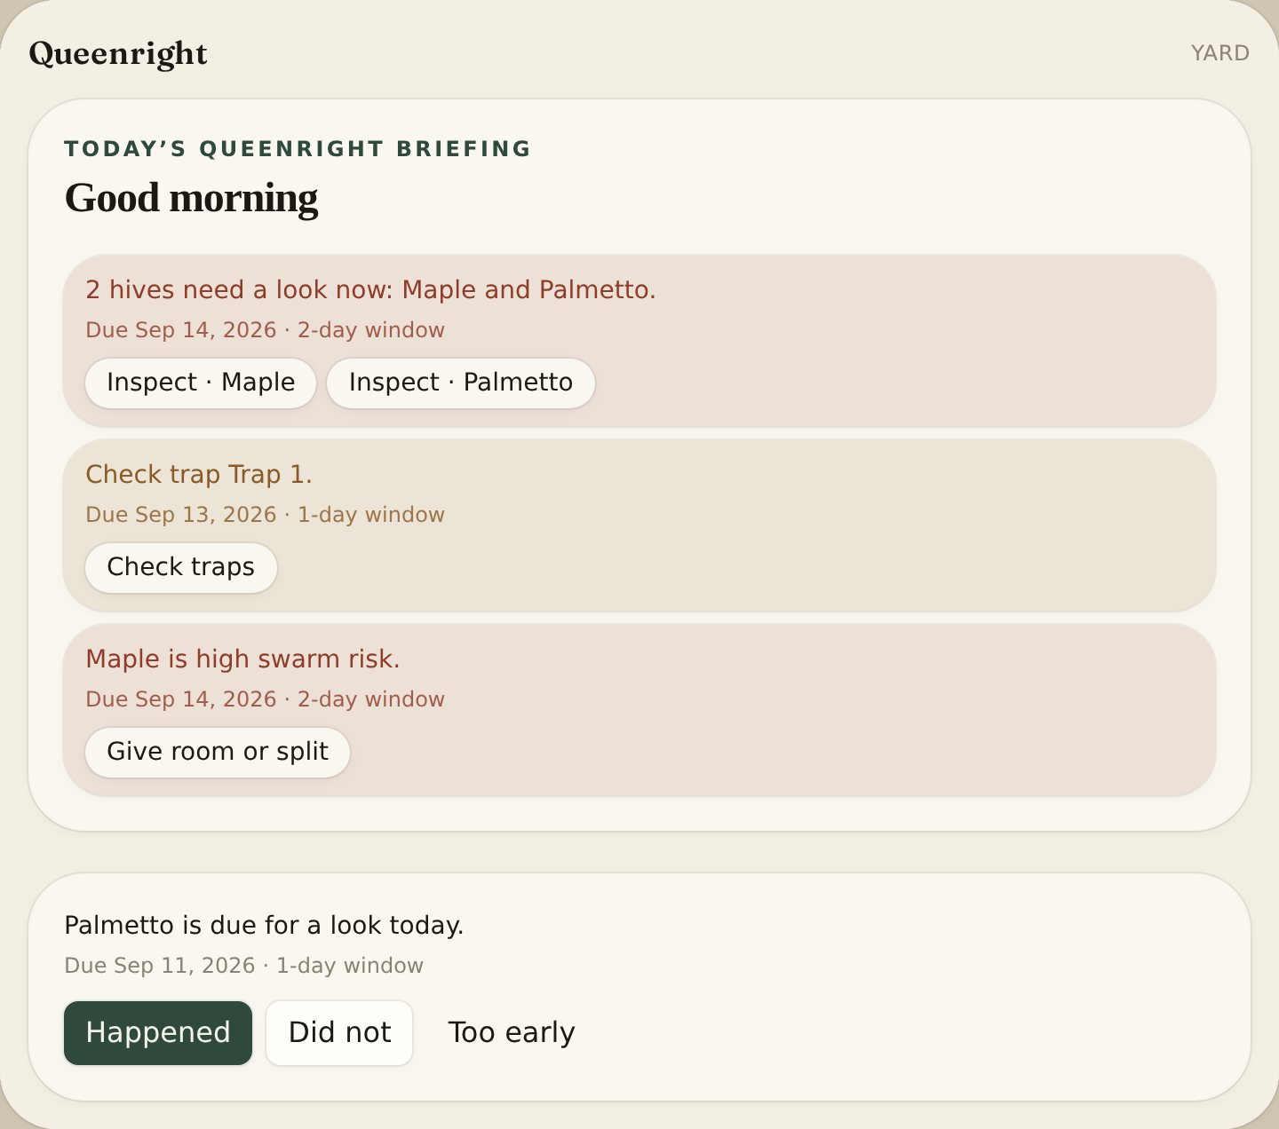
Info:
That work closes the call as Happened. Queenright never auto-misses. A look in that yard also closes that day’s route stop.

Operations this month
Instructions:
- Open Crop. Under Honey production, read Operations.
- The top line is this month: right, early, miss, and still open.
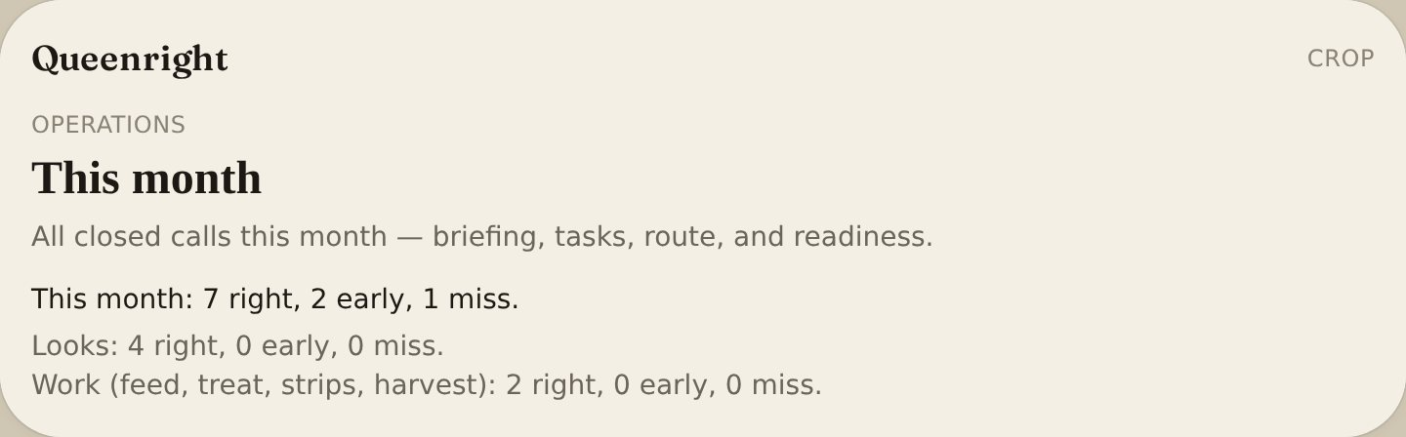
Info:
Lines under that split looks, swarm, no-trap, catch, mating, work (feed, treat, strips, harvest), route, readiness, and nectar flow. Yard briefing shows the same total. Empty until you tap Happened or log the work.

Site score, bloom, weight, photo
Instructions:
- On Map: Find best trap location → Use this spot → save the trap. The catch window stores that score.
- Nectar flow forecast opens a flow call when a plant is soon, beginning, or peak. Log first, peak, or in-bloom to close it.
- A 3 lb weight drop or a photo that flags possible cells only stamps an open look or swarm call. They do not open a new one.
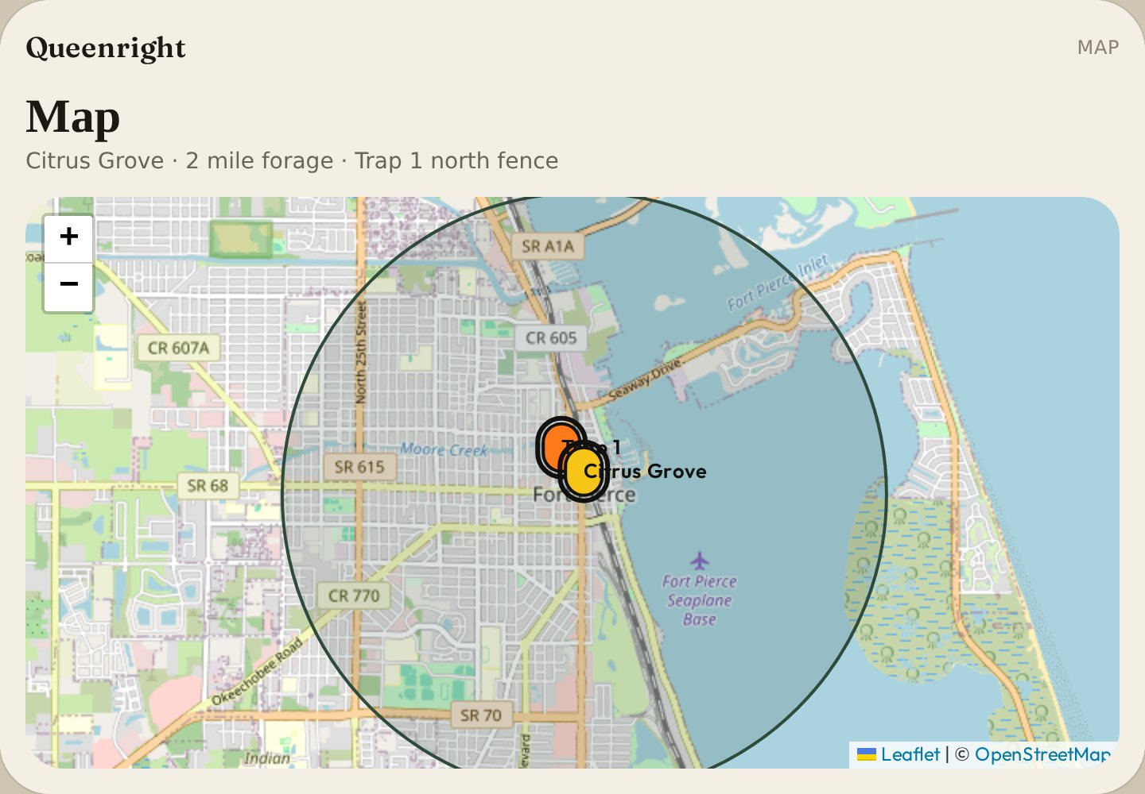
Info:
These predictors join the same ledger. They do not invent a second book.

Parked until the book answers
Instructions:
- On Crop, under Operations, read Models.
- Each line counts closed calls this season: collecting until 8, routine at 8.
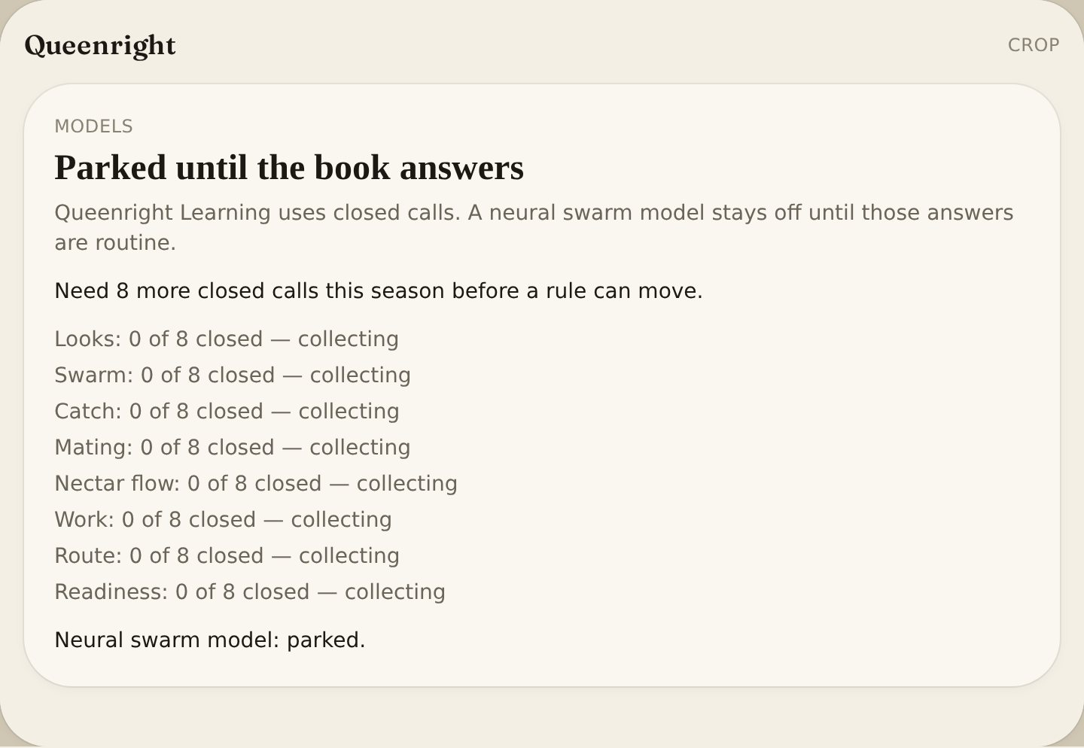
Info:
After 8 closed swarm calls a named rule may move. The neural swarm model stays parked. Queenright will not invent a learned national model while the book is still answering.

Prediction events
Instructions:
- Open Yard. Each briefing line is stored as a call.
Fields
- Kind = look, swarm, strips, harvest, catch, mating, notrap
- Snapshot = why the call was made (cells, last look, bait, scouts, weight, photo, rule name)
- Window = days to act
- Action taken = look, split, super, strips, harvest, trap-set when you log that work

Swarm rule set
Instructions:
- Close swarm calls through the season (tap or log cells / a look).
Info:
After eight closed swarm calls this season Queenright writes a named rule. More false alarms than hits raises High (50 → 58). A split that stops a swarm is not a false alarm — it is supported. More swarms it never called lowers High (50 → 42). Too many Too early adds a day to the window. Until eight closes, stock rules stay.

Hive → trap coverage
Instructions:
- Open a hive.
- Read the swarm-risk card under the score.
Info:
The stand is the yard pin (colonies are not GPS’d separately). Active traps inside the coverage ring (400 yards by default) and last year’s catch on that stand. Pulled and already-caught boxes do not count. Pin the yard on the map first.

Uncovered swarm
Instructions:
- Log swarm cells or set the hive to swarming when no active trap sits in the ring.
- On the briefing tap Set a trap.
- Pin a trap inside the ring.
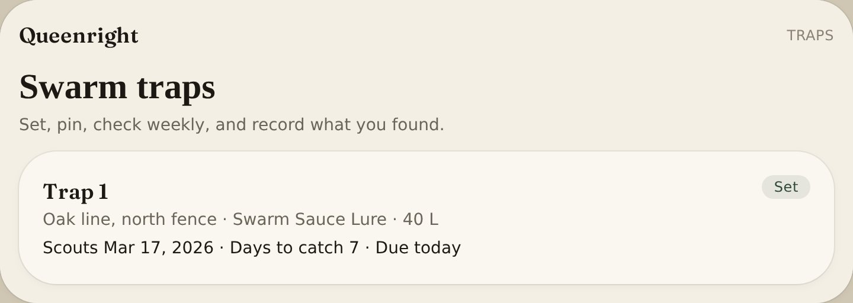
Info:
This is its own call (notrap), not the same as high swarm risk. Window is 7 days. Setting a pinned trap in the ring marks Happened. After eight closed uncovered-swarm calls, too many Did not widens the ring to 500 yards; mostly right tightens it to 350.

Search
Instructions:
- On the phone tap the search icon in the header.
- On a wide screen type in the header search.
- Or open Log and use Search above the list.
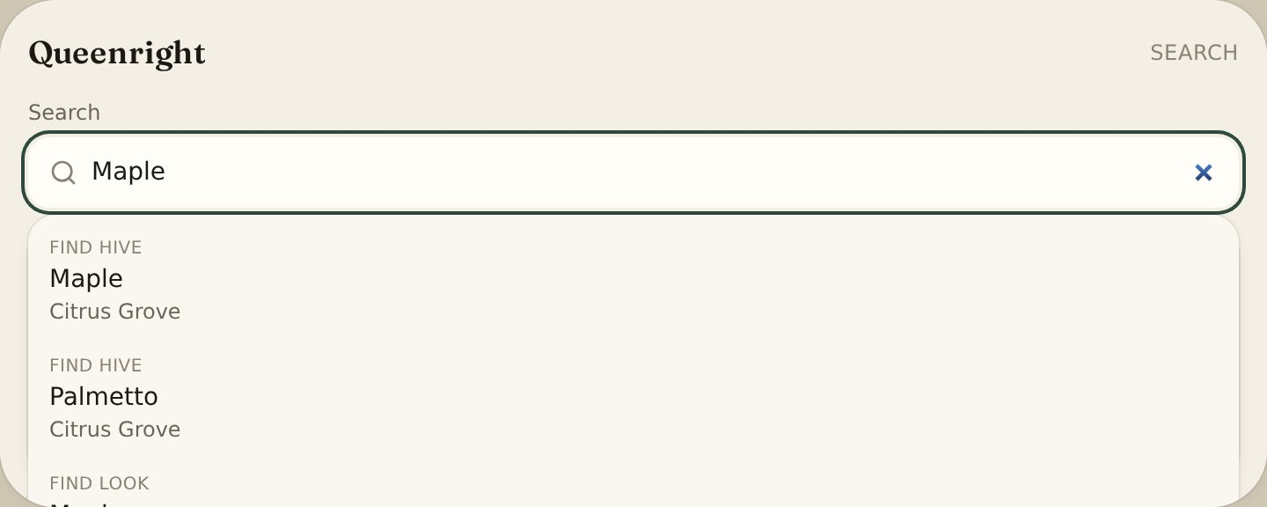
Info:
Finds hives, looks, and traps. Yards and hives sort A–Z; hive 10 comes after hive 9.

From a sentence
Field assistant
Instructions:
- On Yard, under the briefing, open From a sentence.
- Type the plan or tap Speak a plan. Example: Put two more swarm traps around the north side tomorrow and check Hive 14 Friday.
- Review the draft list. Drop a line if it is wrong.
- Tap Save tasks.
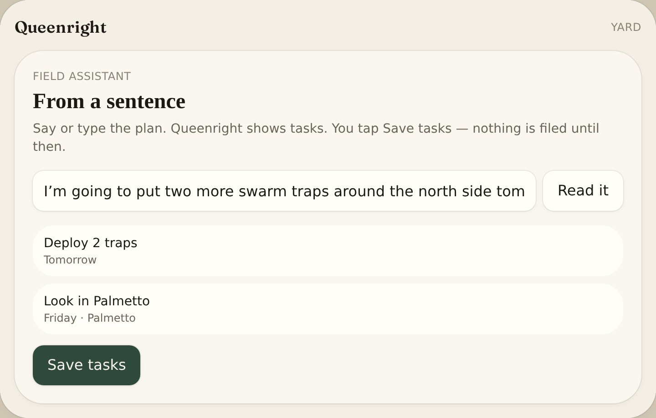
Info:
Tasks land in Your tasks on Season (and Open tasks on Yard). Queenright does not add trap cards or log an inspection until you do that work. The floating mic does the same: a plan sentence opens Yard with the draft.

Crew & route
Sideliner / Commercial
Instructions:
- In Settings set Sideliner or Commercial.
- Open Crew.
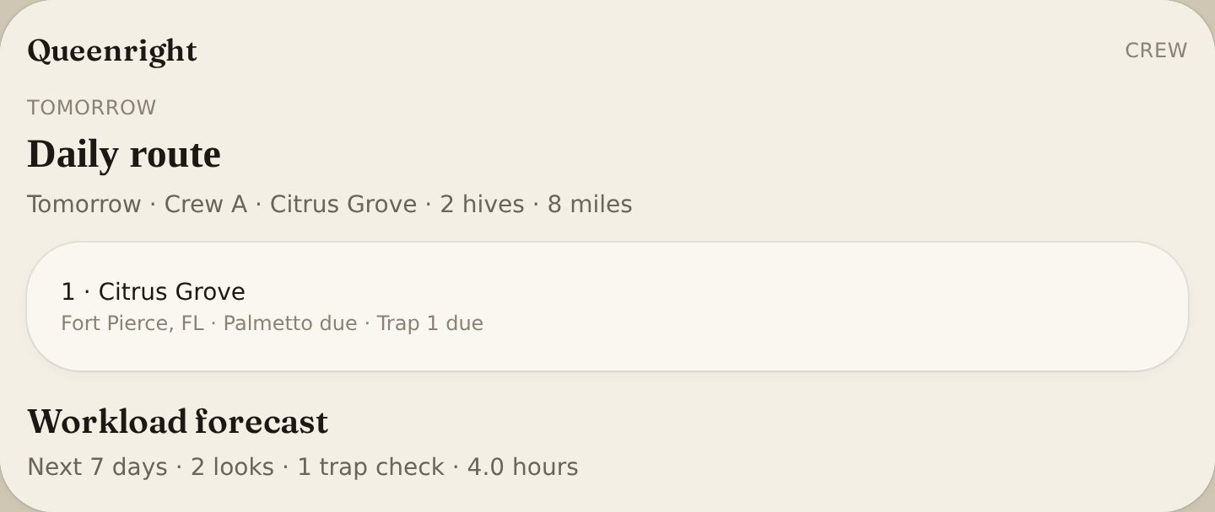
Info:
Daily route groups yards that are due. Workload forecast for the next 7 days counts looks, treatments, trap checks and harvests against available hours.

Truck tools
Packed in the truck — Sideliner / Commercial
Instructions:
- In Settings set Sideliner or Commercial.
- Open Crew. Under Yard equipment, Truck tools is A–Z checkboxes.
- Tap what’s packed: hive tool, smoker, fuel, veil, gloves, brush, frame grip, spray bottle, oxalic vaporizer, alcohol-wash / sugar-shake jar, marking pen, grafting tools, IR thermometer, hive scale, bee suit.
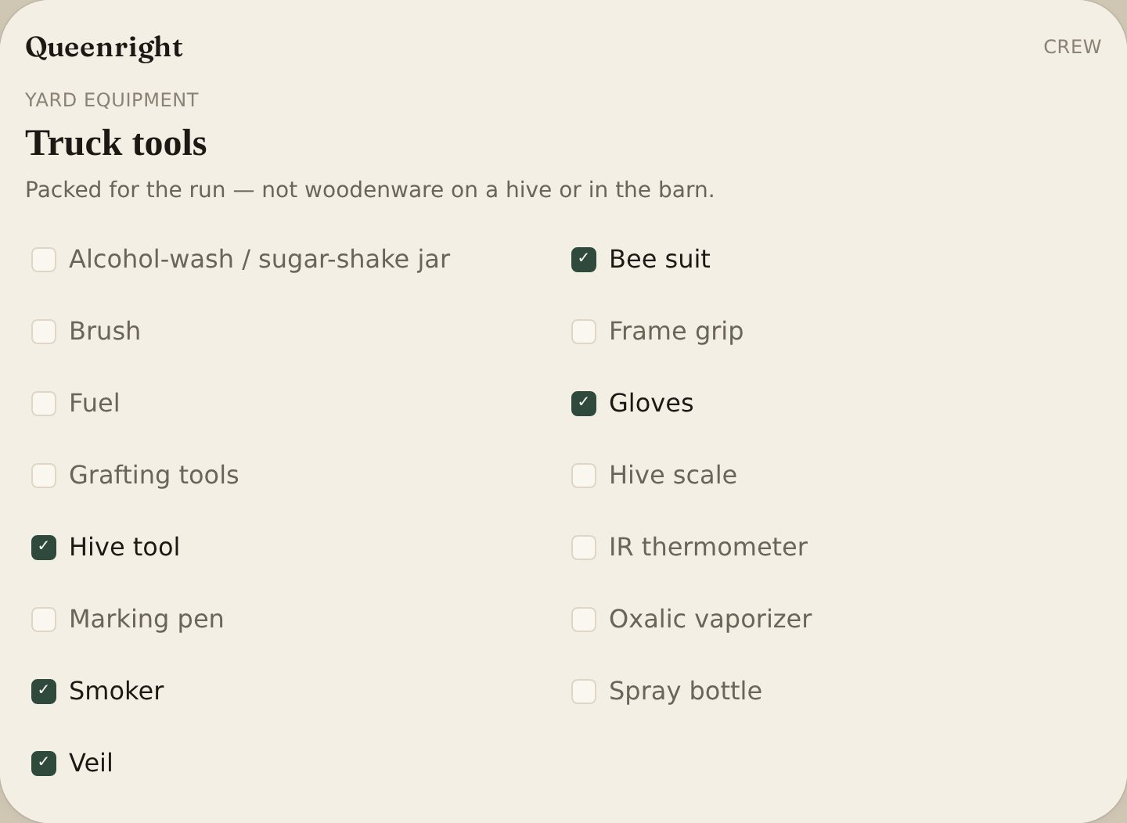
Info:
These are hands tools for the run, not woodenware. Spare boxes stay on This yard’s kit. What’s on the hive stays on the hive card. Checks save to your account.

Print / share the route
Instructions:
- On Crew, open Daily route.
- Tap Print route on one crew, or Print all crews.
- Or tap Share route / Share all crews to send the plan as text (Messages, Mail, WhatsApp).
Info:
One page per crew: people, truck, yards, looks, treatments, traps, harvests, miles, hours, stop order, GPS and access notes. Use the phone if you want Messages.

Workload forecast
Instructions:
- On Crew, read Workload forecast.
Info:
Next 7 days: inspections, treatments, trap checks, harvests, labor required, hours available, and a shortfall if the book is heavier than the crew.

Map
Yards, traps, blooms
Instructions:
- Tap Map.
- Add a bloom. Pick a plant or type one not on the list. Florida holly is on the list (the Florida name for Brazilian pepper). Identify a photo when Grok is wired.
- Use layers for colonies, traps, forage and swarm risk.
Info:
Florida holly uses the same fall window as Brazilian pepper: first bloom about September 1, peak from mid-September through October 20, finished by November 5. Built-in dates start from south Florida and slide by the yard’s latitude and climate. What you log on the pin wins.

Swarm traps
List of traps
Instructions:
- Tap Traps.
Info:
Deployed, due, scouts, caught, empty, absconded, hived, pulled. Catch rate for the season sits under the cards. Hived on and Pulled on dates sit on the trap card.

Add a swarm trap
Instructions:
- Tap Add trap.
- Set Name, Place, Pin, Bait (Swarm Sauce Lure or Other Lure), Type, Height, Volume and Status.
- Add photos. Print a trap card or QR lid from Print, Share or Save. Share trap field card sends the same sheet as text.

Share trap field card
Instructions:
- On Traps, next to Trap field card, tap Share trap field card.
- Or open a trap card and tap Share trap field card.
Info:
Sends name, place, bait, status, scouts, days to catch, last check, and due (Messages, Mail, WhatsApp). Print is unchanged.

Swarm Command Center
Instructions:
- On Traps, read the dashboard.
Info:
Season timing, catch rate by bait, place, type and height, and Swarm Sauce performance (installed, scouts, catch, days to catch).

Season calendar
Instructions:
- Tap Season.
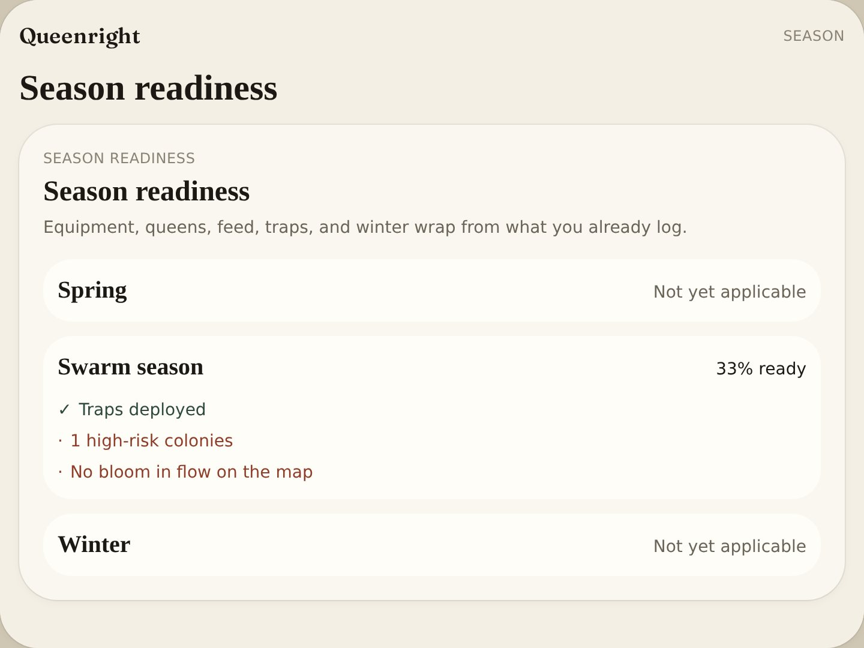
Info:
Follows the climate on Settings or the yard.

Season readiness
Instructions:
- Tap Season.
- Under Traps that are due, read Season readiness.
- Pick a yard at the top if you have more than one.
Info:
Spring scores equipment, queens, recent feed and looks due. Swarm season scores traps not deployed, high-risk colonies and forage on the map. Winter scores fall wrap and mite notes, or Not yet applicable. No extra form — it uses what you already log.

Weather surge
Yard clock — not which hive
Instructions:
- Pin the yard on the map so Queenright can pull daily weather.
- When Home shows a surge line, open Traps for that yard today.
- Open Hives for that yard. Look at High / Very high, cells, or Needs attention if the lid is still safe; otherwise first thing tomorrow.
- If a High hive has 0 traps within 400 yards, set or move a box before tomorrow if you can.
- Tomorrow walk those traps first, then the High boxes.
- On the briefing line tap Happened (scouts, a catch, or a swarm) or Did not.
Info:
Example: “Surge at Tree Tops: confined 3 days · tomorrow warm and clear · 7926 GDD.” Confined 3 days = poor flight weather. Tomorrow warm and clear = flyable next day (about 68–92°F). GDD is heat from 1 January (base 50°F). In South Florida by September that number is always large — not a 7,926% chance of a swarm. The 1-day window is tomorrow. The line does not name which hive. Check traps first.

How swarming is decided
The mark is not the score
Instructions:
- Open the hive. Read Swarm risk on the card.
- Log the look. Enter swarm cells. Save.
Info:
A hive is marked swarming only from the look you save. The number on the card is a warning, not the mark. Swarm risk is a 0–100 warning from the latest look. It does not, by itself, mark the hive swarming.
Fields
- 3 or more swarm cells marks the hive swarming — only if it is queenright or a nuc.
- 1 or 2 cells do not change the status. Queenless, dead, and removed stay as they are. You can also set Swarming by hand.
- Outside swarm season, points so far are cut to 45%. Overdue-look points apply only in season. Add a super still adds 5 after the cut.
- A nuc stops at 42. Queenless is forced to 8, Low, and skips the points. Dead or removed scores 0.
- Stock thresholds: High at 50, Very high at 75. Learning can move those after enough closed swarm calls.
- Very high, or 3 or more cells on that look: look within 24 hours. High: 48 hours. About half of High, and at least 20: Moderate, this week. Below that: Low, normal cadence.
- Graded on the next look, separate from Today’s briefing. High or Very high counts only if the next look still has swarm cells, or the hive is still marked swarming and no later look closed it.
- A split, a super, or pulled cells, then zero cells, is a miss on this score — you stopped it. A Low call, then cells, is a miss the other way.
- Supersedure cells are saved and are not part of this score. The Learning strip on Yard grades a prevented swarm on its own line. That strip is not this number.

Swarm risk points
Added from the latest look
Info:
These points make the 0–100 warning. They do not mark the hive swarming. Already swarming treats the cells as many. See How swarming is decided for the season cut, the caps, and how the next look grades the score.
Fields
- Already swarming = 45
- 3 or more swarm cells = 40
- 1–2 swarm cells = 22
- The look before also had cells = 8
- Strong brood = 14. Fair brood = 6
- Queen present = 6. Queen 2 years or older = 6
- High congestion (16 or more frames, or 3 or more boxes) = 16
- Moderate congestion (10 or more frames, or 2 boxes) = 8
- Heavy honey = 8. Adequate honey = 3
- Peak swarm month = 12. In swarm season = 6
- No look for 10 or more days in season = 14. 7 or more days = 8. Never looked in season = 10
- Next action is add a super = 5

Profit
List of entries
Instructions:
- Tap Profit.
- Pick the year.
- Tap Add entry.
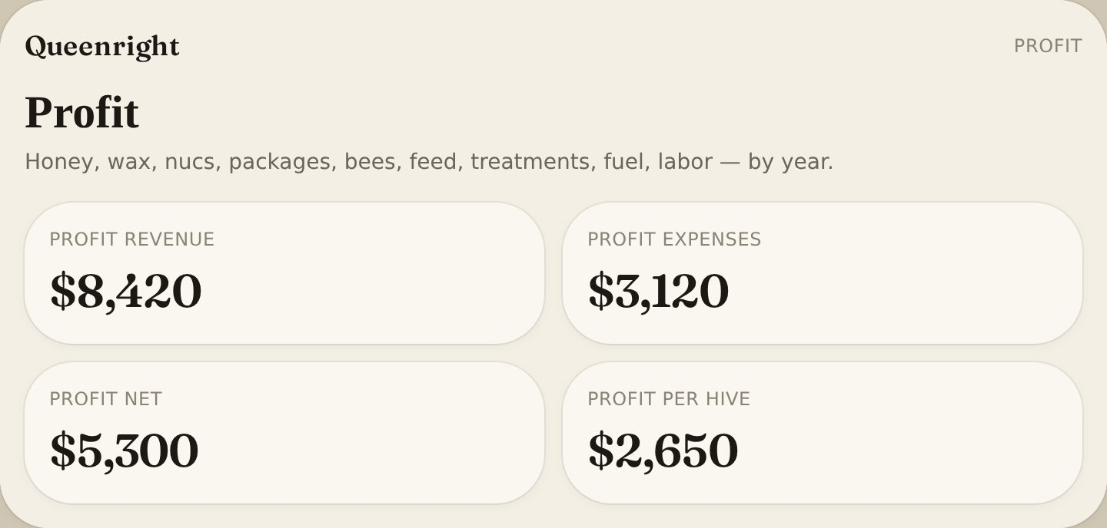
Info:
Income and expense for the operation, one year at a time. Revenue per live hive. The current year is always listed. Any earlier year with a sale or an expense gets its own chip. Tap a year for that year’s totals, categories, rearing costs, and line items.

Add a profit entry
Instructions:
- Tap Add entry.
- Set Date, Category, Amount, Yard or Hive and Notes.
- Tap Save.
Fields
- Categories include bees, queens, feed, treatments, equipment, fuel, packaging, harvest supplies, swarm lure, labor, honey, wax, propolis, nucs, packages

Queen rearing costs
Instructions:
- On Profit, tap Add event costs.
- Pick the rearing event.
- Enter hours, rate and dollar lines.
- Set losses and successful laying queens.
Info:
Cost per successful laying queen — not cost per graft.

Queens
List of rounds (Sideliner / Commercial)
Instructions:
- In Settings set Sideliner or Commercial.
- Tap Queens.
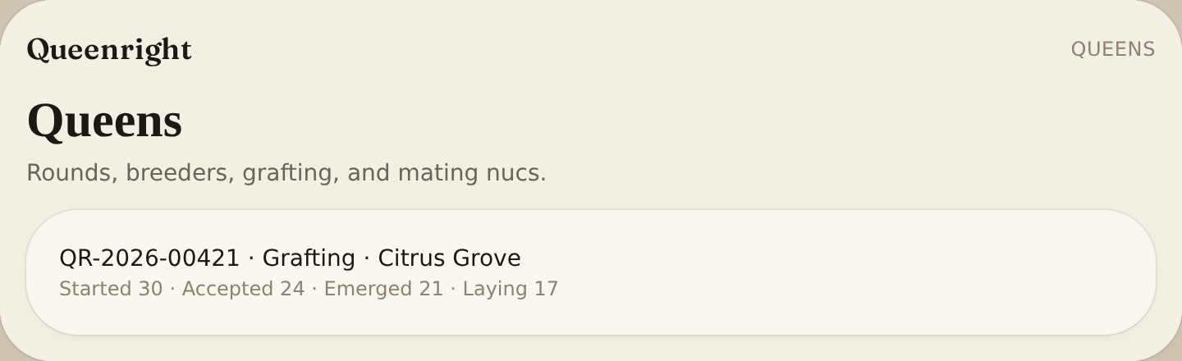
Info:
Rearing events with calendar dates from graft day. Event tree, cell map, mating nucs, photos, quality scores, and Predicted vs actual.

Predicted vs actual
Rearing intelligence — Sideliner / Commercial
Instructions:
- In Settings set Sideliner or Commercial.
- Tap Queens. Under the round totals, read Predicted vs actual.
- Add a round and count grafts. Queenright writes the odds from larva age, builder strength, and feed.
- Log accepted, emerged, mated, and laying. Actual fills from those counts.
Info:
Odds freeze at the graft. Predicted does not move. On the call = within 8 points. Predicted high = the odds were hot. Predicted low = the book beat the call. Weighted across rounds. Each round’s tree shows the same four bars.
Fields
- Acceptance = accepted / grafted
- Emergence = emerged / accepted
- Mating = mated / emerged
- Laying = laying / mated (or emerged)

Add a rearing event
Instructions:
- Tap Add round.
- Set Yard, Date initiated, Method, Purpose, Counts (started, accepted, emerged, mated, laying), Operator and Notes.
- Add breeder, graft source, larval age, cell builder scores, mating-yard GPS and cell map.
Fields
- Rearing Event ID = QR-YEAR-00000
- Larval age = 12–24 h / 24–36 h / 36–48 h / exact hours
- Cell map = tap a cup: empty → grafted → accepted → emerged → rejected → laying

Cell log — incubator
One line on the round
Instructions:
- On Queens, open a round.
- Under Cell development, tap Add cell.
- Set Time in, Cage by, and Held (°F). Save.
Info:
Cage by starts at the graft time plus 12 days — the same emerge date as the round. Change the hour. The line uses the earliest time in and the earliest cage-by in that round, plus the temperature. Mating and laying stay on the day calendar.
Fields
- Time in = when the cells went into the incubator
- Cage by = when you must cage them, before sister queens emerge together
- Held = temperature you kept, in °F (about 93°F)

Queen quality
Instructions:
- On Queens, tap Score a queen.
- Leave any trait Not measured.
Fields
- Brood pattern, Temperament, Population, Mating quality, Egg-laying pattern
- Hygienic behavior, Swarming tendency, Disease resistance, Honey production, Overwintering
- Score = 1–5 or Not measured

Share a yard
Instructions:
- Open the yard.
- Tap Share.
- Send the link. Helpers can view and add inspections.
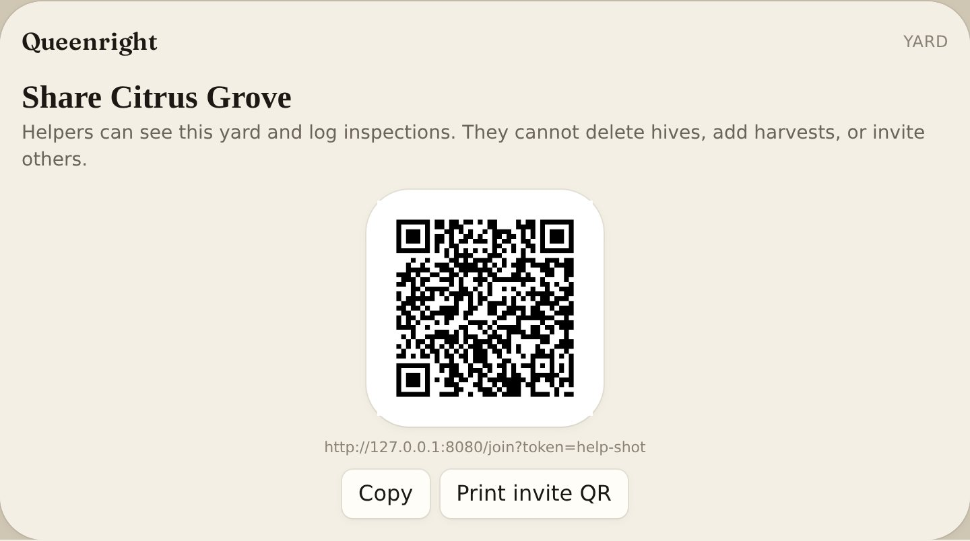

Share field card
Instructions:
- On Yard, next to Print field card, tap Share field card.
- Send pin, access, owner, this yard’s apiary number, neighbor spray, hive names, last look and due through Messages, Mail or WhatsApp.
Info:
Print field card is the same sheet on paper. The apiary number on the sheet is this yard’s number, not the inspector number on Settings. Share (invite) is still how you add a helper.

Backup
Instructions:
- Open Settings.
- Export JSON or CSV.
- Import JSON from another yard book.
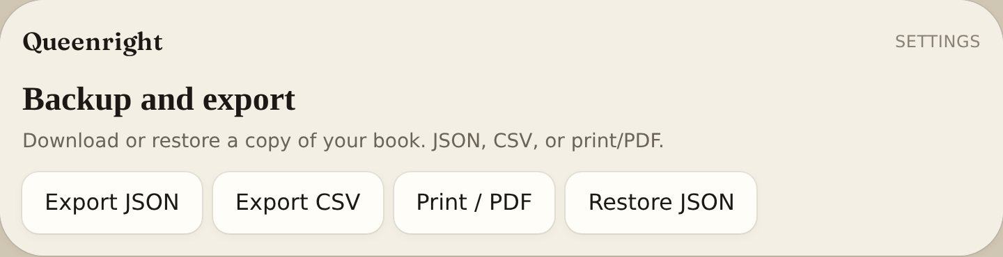

Offline
Instructions:
- Work in the yard with no signal.
- Looks queue and upload when you are back.
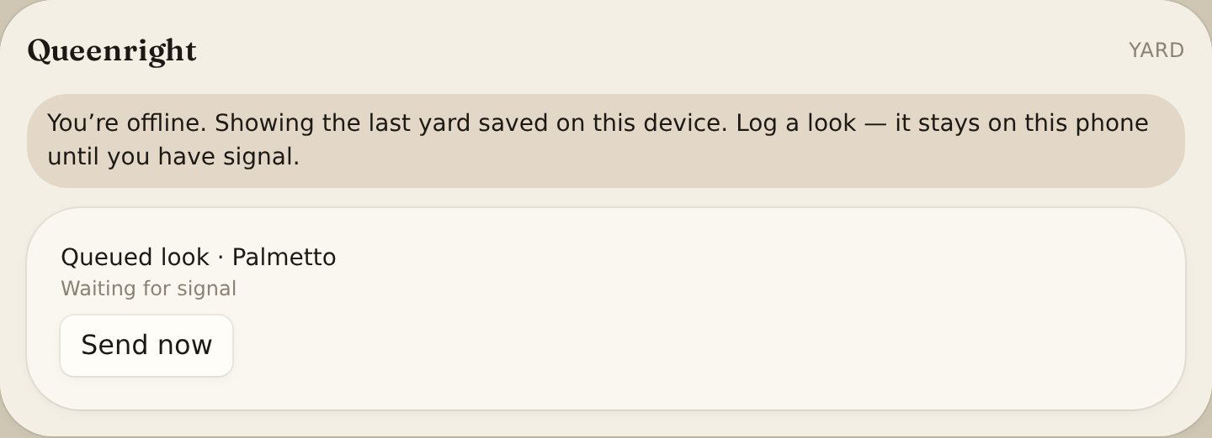

Phone & language
Instructions:
- In Chrome tap Add to Home Screen.
- In Settings pick English or Spanish. Voice commands use that language.
- If a page is text-only after a publish, clear site data or tap Reload Queenright.
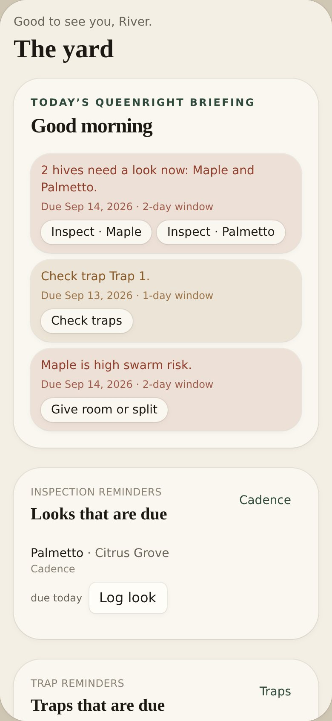

How data is stored
Instructions:
- Sign in. Your yards live on the Queenright server for your account.
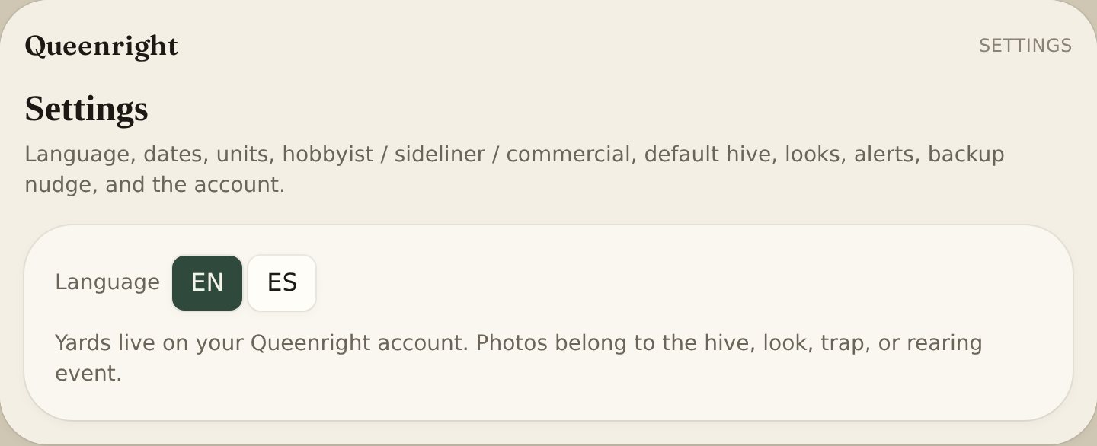
Info:
Clearing the phone cache does not delete yards. Photos belong to the hive, look, trap or rearing event.

Privacy
Instructions:
- On Sign in, Settings, or How to use, tap Privacy.
- Read Location first.
Info:
Yard pins, apiary numbers, and photos sit on your account. Queenright does not sell them and does not list your apiary on a public map. A pin is for your map, forage, weather, and the print or share you start — not a directory. Helpers only see yards you invite them to.
Fields
- Location = map, forage, weather, print/share you start. Not a public directory.
- Apiary numbers = inspector copy and that yard’s field card, not a public registry in the app.
- Photos = stay on the hive, look, trap, or queen. Sharing is something you do.
- What leaves = weather for a pin, sign-in, Print/Share, and voice or photo reads you start.
- Delete = Settings → Delete account. Shared yards you only help on stay with the owner.

Terms
Instructions:
- On Sign in, Settings, or How to use, tap Terms.
Info:
You keep one account. Helpers see yards you share and can add looks — they do not own the book. Print and share send the sheet (pin, access, owner, this yard’s apiary number, hive names) — only to people who should stand at that gate. Treatments and queen calls are reminders, not veterinary or legal advice.

Always free
The Queenright app will always be 100% free and includes the full features. You will never have to pay later after the yards are set up. Thank you for being a Swarm Sauce customer. No purchase required.
©2025-2026 Swarm Sauce, LLC - Swarm Sauce® and Queenright® are copyright and registered trademarks of Swarm Sauce, LLC. All Rights Reserved. First use in commerce 10/01/2025.

